**…….……. - ……….… EDUCATIONAL YEAR**

**……………………………………………………. SECONDARY SCHOOL**

**6TH GRADE 2ND TERM 2ND EXAM**

Duration: 40 minutes

Name-Surname:……………………………………… Class:…………… Number:………

1. **Match the occupations with the pictures.**

**A.** cook **B.** waiter **C.** driver **D.** teacher **E.** vet **F.** dentist **G.** hairdresser **H.** tailor **I.** mechanic **J.** nurse

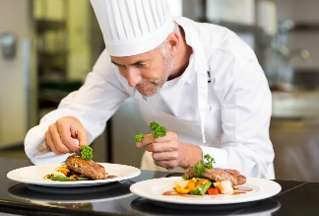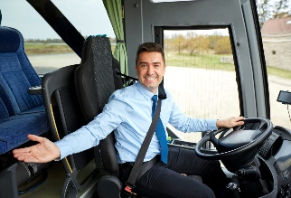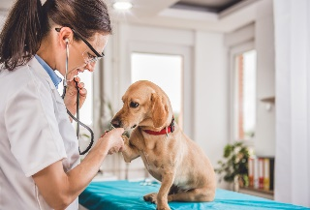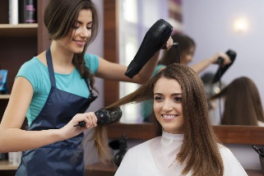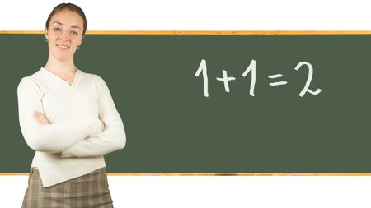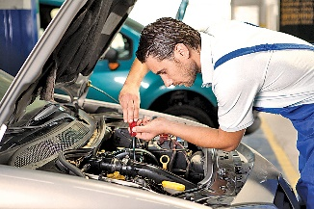

1. 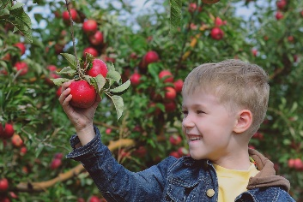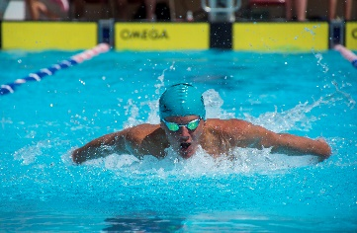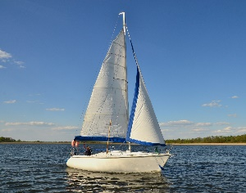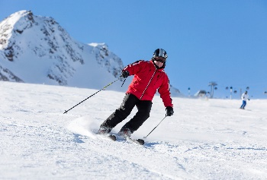**Match the activities with the pictures.**

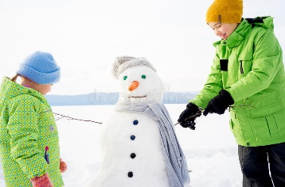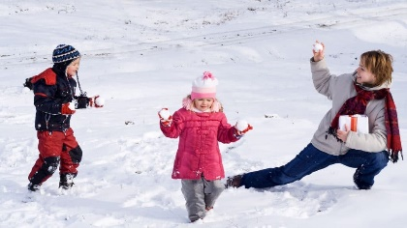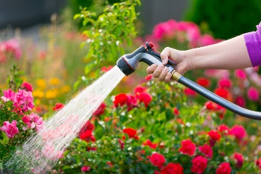

1. swimming
2. sailing
3. making a snowman
4. skiing
5. picking fruit
6. playing snowball
7. watering flowers
8. 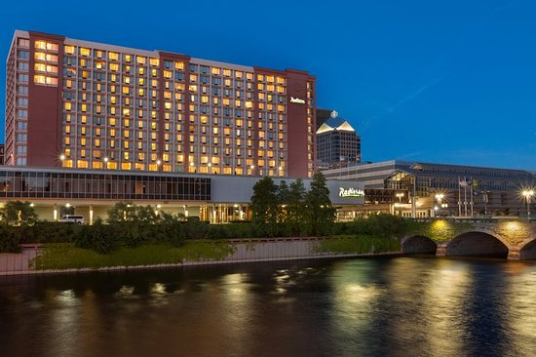**Read the hotel brochure and write true (T) or false (F).**

RIVERSIDE HOTEL

____ The hotel is by the sea.

____ There are winter activities at the hotel.

____ There is a fitness center in the hotel.

____ There is only one sauna in the hotel.

____ Kids can have fun at the aqua park.

* Swimming pool
* Aqua park for both kids and adults
* Fitness center
* Kids club
* Jacuzzi & Sauna in every room
* Breakfast & Lunch & Dinner Buffet
* Rafting in Summer

River Region – 00 44 211 678 90 33

1. **Look at the photos and complete the sentences with the prepositions in the box.**

**A.** in **B.** in front of **C.** under **D.** on **E.** behind **F.** near **G.** between

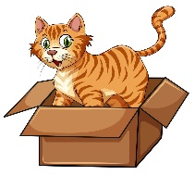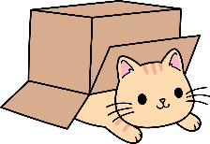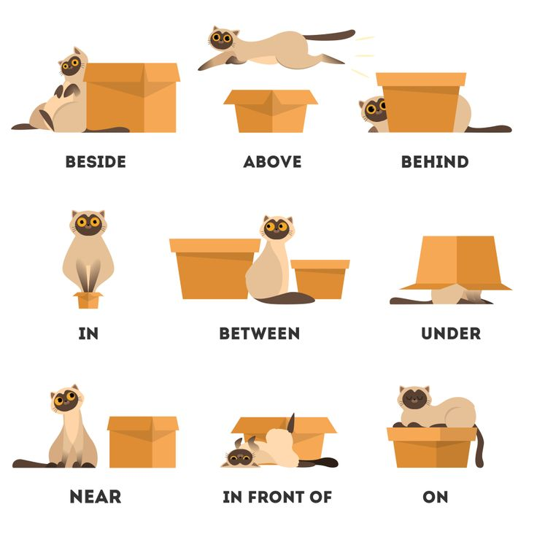

The cat is __________ the box.

The cat is __________ the box.

The cat is __________ the box.

The cat is __________ the box.

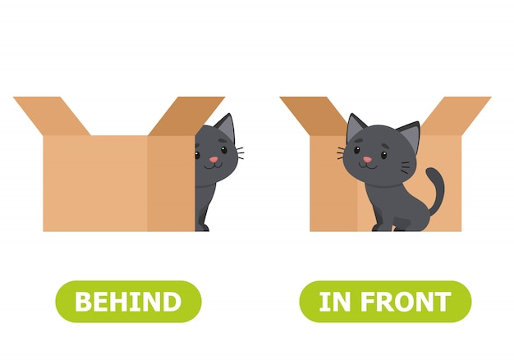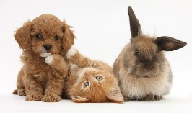

The cat is __________ the box.

The cat is __________ the dog and rabbit.

The cat is __________ the box.

1. **Match the words with their definitions.**

**A.** to look up _____ to search for someone or something

**B.** to look for _____ to direct your eyes to someone or something

**C.** to look at _____ to try to find some information in a book or on the Internet

1. **Read the instructions and rewrite the sentences using “should” or “shouldn’t”.**

**A.** Keep the environment clean. 🡪 __________________________________________________________.

**B.** Don’t pollute the seas. 🡪 __________________________________________________________.

**C.** Don’t waste water. 🡪 __________________________________________________________.

**D.** Stop air and water pollution. 🡪 __________________________________________________________.

1. **metin, yazı tahtası içeren bir resim

   Açıklama otomatik olarak oluşturulduChoose the correct option.**

**………………………………**

**English Language Teacher**

**A.** You ***should / shouldn’t*** cut down trees.

**B.** You ***should / shouldn’t*** use less water and energy.

**C.** You ***should / shouldn’t*** recycle.

**D.** You ***should / shouldn’t*** throw rubbish.