**Test Yourself**

1. **Complete the words.**

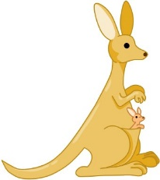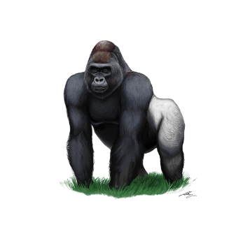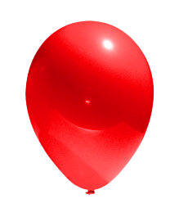

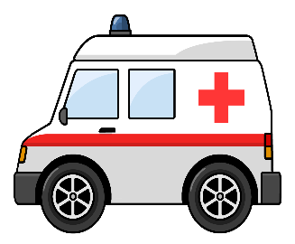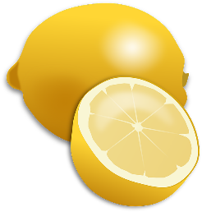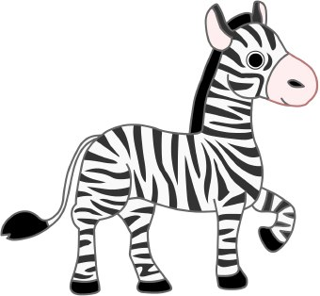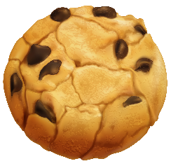

**z _ b _ a**

**_ as _ et _all**

**a _ b _ la _ ce**

**l _ m _ n**

**_ is _ u _ t**

**t _ le _ is _ o _**

**_ ak _**

**_ al _ oo _**

**g _ r _ ll _**

**k _ ng _ r _ o**

1. **Find the words in the puzzle.**



|  |  |  |  |  |  |  |  |  |  |
| --- | --- | --- | --- | --- | --- | --- | --- | --- | --- |
| **P** | **I** | **Z** | **Z** | **A** | **S** | **H** | **O** | **L** | **V** |
| **D** | **F** | **G** | **T** | **P** | **A** | **N** | **D** | **A** | **Z** |
| **O** | **A** | **E** | **X** | **C** | **L** | **W** | **E** | **B** | **T** |
| **C** | **H** | **I** | **M** | **P** | **A** | **N** | **Z** | **E** | **E** |
| **T** | **X** | **R** | **N** | **L** | **D** | **M** | **E** | **I** | **N** |
| **O** | **G** | **R** | **A** | **D** | **I** | **O** | **A** | **A** | **N** |
| **R** | **F** | **O** | **O** | **T** | **B** | **A** | **L** | **L** | **I** |
| **Q** | **S** | **A** | **N** | **D** | **W** | **I** | **C** | **H** | **S** |
| **T** | **R** | **A** | **I** | **N** | **A** | **V** | **I** | **F** | **Q** |
| **D** | **P** | **E** | **Q** | **C** | **O** | **F** | **F** | **E** | **E** |

