MY BODY PARTS

Head

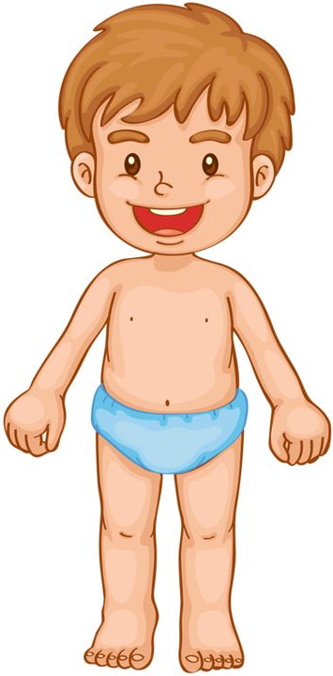
Hair
Eye

Ear
Mouth
Nose
Shoulder

Hand
Arm

Finger

Leg
Knee

Foot
Toe

