[www.ingilizcele.com](http://www.ingilizcele.com)

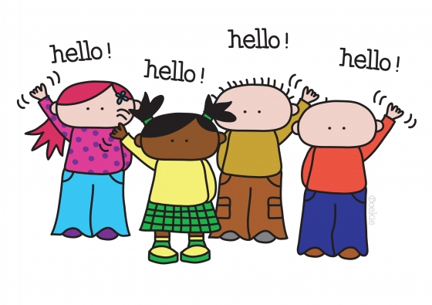

**GREETING**



**HI.**

**HELLO.**



**MY NAME IS SHEILA.**

**WHAT IS YOUR NAME?**



**NICE TO MEET YOU, TOO.**

**NICE TO MEET YOU.**



**HOW OLD ARE YOU?**

**I’M EIGHT YEARS OLD.**



**HAVE A GOOD DAY.**

**HAVE A NICE WEEKEND.**



**SEE YOU SOON.**

**TAKE CARE.**



**BYE.**

**GOODBYE.**