Test Yourself
- Find the words in the puzzle.
GRANDFATHER – GRANDMOTHER – FATHER – MOTHER – BROTHER – SISTER – UNCLE – AUNT – COUSIN

E | N | B | U | W | L | O | G | Z | U | N | C | L | E | H | G | I
N | S | I | S | T | E | R | F | C | U | D | Z | E | Q | X | R | O
K | R | U | U | V | X | P | C | O | U | S | I | N | O | M | A | H
B | T | A | Y | T | K | N | V | Q | T | R | P | X | M | K | N | W
R | J | S | G | R | A | N | D | M | O | T | H | E | R | H | D | F
O | H | G | P | U | M | P | J | T | S | Q | A | A | K | J | F | P
T | B | Q | L | I | O | E | E | K | P | M | N | L | O | Y | A | Y
H | N | X | O | P | T | R | X | J | U | O | T | H | R | E | T | G
E | D | T | H | Y | H | W | F | A | T | H | E | R | S | D | H | M
R | E | B | V | I | E | U | W | R | L | J | S | K | L | J | E | I
S | W | K | I | R | R | E | O | G | A | U | N | T | R | U | R | A

- Match the words with the pictures.
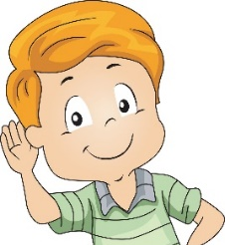
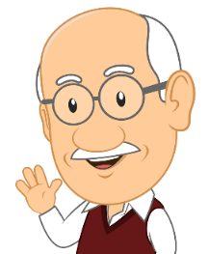
A. He is my father.

B. This is my sister.

C. She is my grandmother.

D. He is my brother.

E. This is my mother.

F. This is my grandfather.

