Test Yourself
- Unscramble the words.

REHFTA
……………………
………………………
CUELN
MOGHRNATEDR
UATN
OHMTRE
…………………
…………………
……………………………
TSIESR
INUCSO
RBHEOTR
FHEGNRATARD
……………………
……………………
………………………
……………………………

- Match the names with the family members.
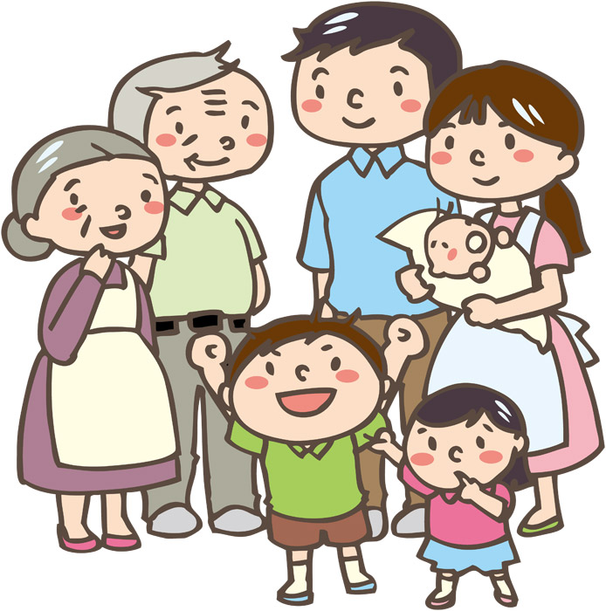
David
Alex
Claire
Peter
Susan

*Father: ____________

*Mother: ____________

*Sister: _____________

*Grandmother: __________

*Brother: __________

*Grandfather: __________

Sara

ME

