|  |  |  |  |  |  |  |  |  |  |
| --- | --- | --- | --- | --- | --- | --- | --- | --- | --- |
| **A**  Göz | **B**  Brontozor | **C**  Yapboz | **D**  Yıldızlar | **E**  **Gözlük** | **F**  **Örümcek ağı** | **G**  **Simge Durumuna Küçült** | **H**  **Kardanadam** | **I**  **Ekranı Kapla** | **J**  **Fil** |
| **K**  **Atom** | **L**  **Gönderme** | **M**  **Harita pusulası** | **N**  **Sıcak hava balonu** | **O**  **Sapsız çiçek** | **P**  **Sıçrama** | **Q**  **Çörek** | **R**  **Yenile sağdan sola** | **S**  **İşaret Dili** | **T**  **Yay** |
| **U**  **Kaydet** | **V**  **Balonlar** | **W**  **Yenileme** | **X**  **Futbol topu** | **Y**  **Tahıl tanesi** | **Z**  **Elmas** |

www.ingilizcele.com

1. ***Write the words. Then, match the words to the pictures.***





**______________________________**



********

**_________________________**

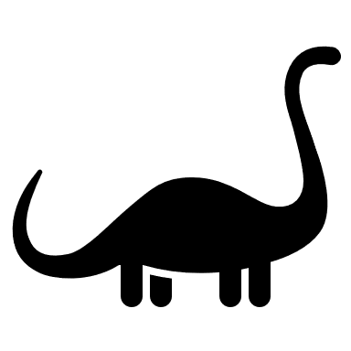********

**____________________________________**



**__________________________**

********

**____________________________________**

********

**_________________________**

**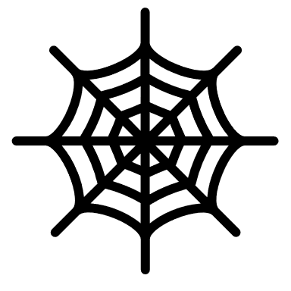**********

**________________________________**

|  |  |  |  |  |  |  |  |  |  |
| --- | --- | --- | --- | --- | --- | --- | --- | --- | --- |
| **A**  Göz | **B**  Brontozor | **C**  Yapboz | **D**  Yıldızlar | **E**  **Gözlük** | **F**  **Örümcek ağı** | **G**  **Simge Durumuna Küçült** | **H**  **Kardanadam** | **I**  **Ekranı Kapla** | **J**  **Fil** |
| **K**  **Atom** | **L**  **Gönderme** | **M**  **Harita pusulası** | **N**  **Sıcak hava balonu** | **O**  **Sapsız çiçek** | **P**  **Sıçrama** | **Q**  **Çörek** | **R**  **Yenile sağdan sola** | **S**  **İşaret Dili** | **T**  **Yay** |
| **U**  **Kaydet** | **V**  **Balonlar** | **W**  **Yenileme** | **X**  **Futbol topu** | **Y**  **Tahıl tanesi** | **Z**  **Elmas** |

1. ***Decode the messages and answer the questions.***

********

**_______________**



********

**_____________________**



**________________**



**________**

**…………………………………………………………………………………………………………………………………….**



**______________________**





**____________**



**__________**



**______________________**

**…………………………………………………………………………………………………………………………………….**



**___________**



**___________**

************

**_________________________________________**

********

**_______________**



**________________**



**____________**



**____________**

**…………………………………………………………………………………………………………………………………….**





**_____________________**

**…………………………………………………………………………………………………………………………………….**