Test Yourself
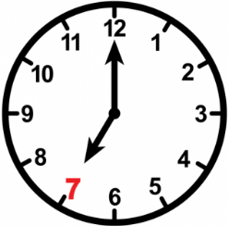
- Match sentences with the clocks.
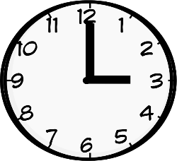
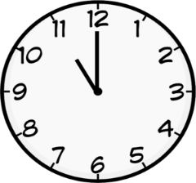
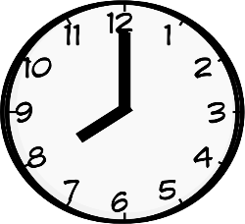
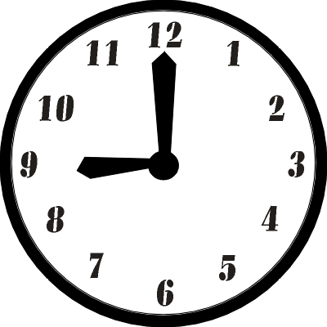
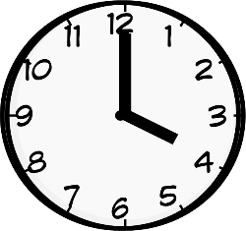
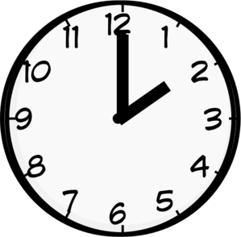
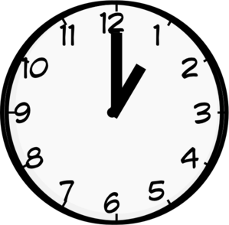
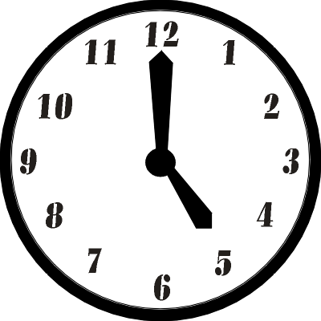
- It’s nine o’clock.
- It’s three o’clock.
- It’s four o’clock.
- It’s one o’clock.
- It’s five o’clock.
- It’s eight o’clock.
- It’s eleven o’clock.
- It’s two o’clock.
- It’s seven o’clock.

- Find the words in the word search. Then, write.
…………….………... lunch
…………….………... up
…………….………... teeth
…………….………... hair
…………….………... to school
…………….………... TV
…………….………... friends
…………….………... homework
…………….………... face
…………….………... books
E | Q | W | H | T | U | Y | C | O | M | B
G | U | H | K | I | A | P | L | M | A | V
C | M | A | J | F | D | E | E | T | H | T
Y | R | V | A | A | F | R | W | U | I | K
N | V | E | H | Y | W | A | K | E | R | U
B | M | N | Z | C | E | X | O | P | G | R
M | E | E | T | H | N | T | E | Q | L | E
M | P | O | R | S | S | F | H | U | Y | A
N | U | B | R | U | S | H | T | W | Z | D
Z | A | A | Y | T | E | O | L | L | K | W
F | X | C | B | N | M | H | J | D | S | A
Y | T | R | E | I | W | A | T | C | H | L
L | G | H | B | B | T | E | U | P | V | C
J | W | A | S | H | X | P | G | T | E | B
G | O | V | M | N | Y | R | W | Q | D | O

