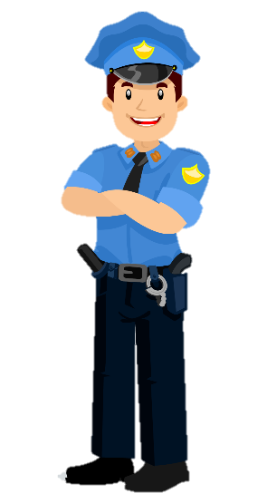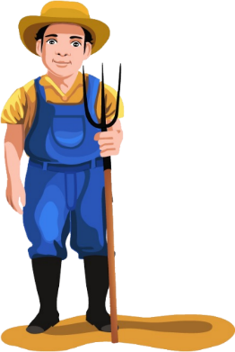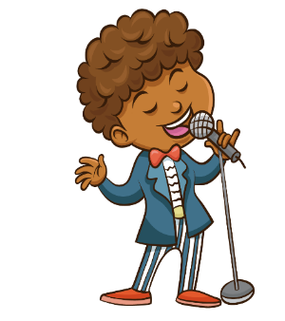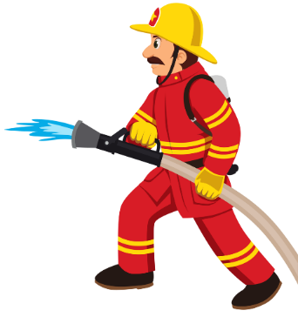



**JOBS**







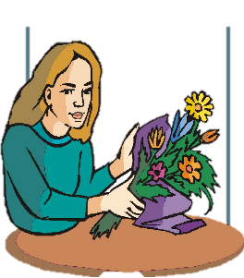







**She works at a school.**

**He is a doctor.**

**She is a teacher.**

**He likes examining patients.**

**He works at a hospital.**

**She likes teaching children.**





**She is a nurse.**

**He is a dentist.**

**He likes pulling out teeth.**

**He works at a hospital.**

**She likes helping doctors.**

**She works at a hospital.**





**She is a vet.**

**He is a policeman.**

**He likes directing the traffic.**

**She likes helping animals.**

**He works at a police station.**

**She works at a veterinary clinic.**



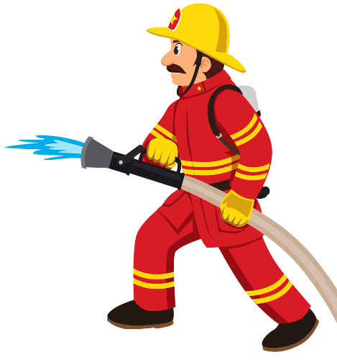

**He is a fireman.**

**He is a postman.**

**He likes putting out the fire.**

**He likes delivering letters.**

**He works at a fire station.**

**He works at a post office.**





**He is a pilot.**

**He is a chef.**

**He likes cooking meals.**

**He likes flying planes.**

**He works at a restaurant.**

**He works at an airport.**





**He is a baker.**

**He is a waiter.**



**He likes making bread.**

**He likes serving food and drinks.**

**He works at a restaurant.**

**He works at a bakery.**

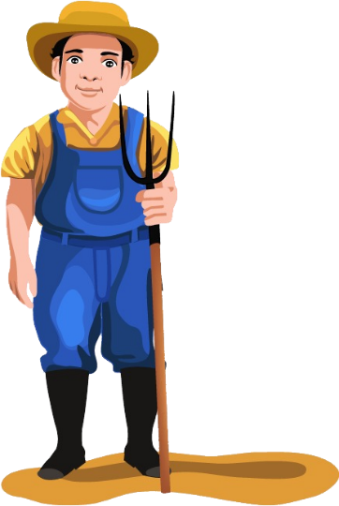



**She is a tailor.**

**He is a farmer.**





**She likes cutting and sewing clothes.**

**He likes growing vegetables.**

**She works at a tailor shop.**

**He works on a farm.**

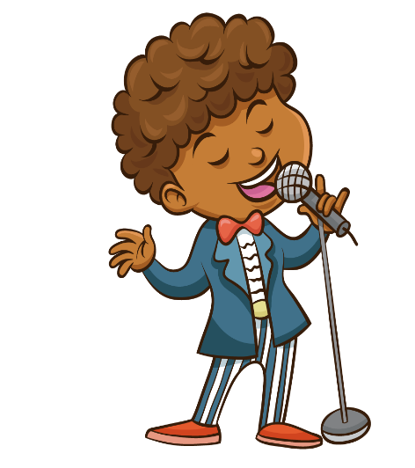



**He is a singer.**

**She is a dancer.**

**He likes singing songs.**

**She likes dancing.**

**She works at a dance school.**

**He works at a music hall.**

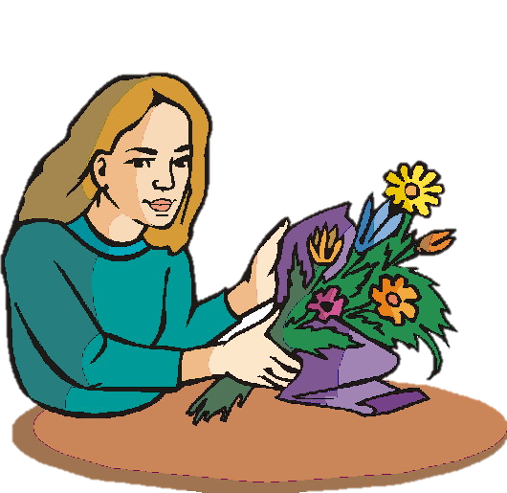

**He works at a garden.**

**She is a florist.**

**He likes gardening and planting.**

**She likes selling flowers.**

**She works at a flower shop.**

**He is a gardener.**

