……………. – …………… EDUCATIONAL YEAR
………………………………………….. PRIMARY SCHOOL
4TH GRADE 1ST TERM 1ST EXAM
Duration: 40 minutes
Name-Surname:……………………………………… Class:…………… Number:………

- Write the numbers in words. (10*3=30 points)
1 2 3 4 5
6 7 8 9 10

__________ __________ __________ __________ __________

__________ __________ __________ __________ __________
- Write the numbers. (10*2=20 points)
A) Eleven ............................... F) Forty-six ...........................
B) Fourteen ............................... G) Thirty-nine ...........................
C) Seventeen ............................... H) Twenty-two ...........................
D) Twenty ............................... I) Forty-three ...........................
E) Thirty-five ….........................… J) Fifty ...........................

- Match the countries with the nationalities. (7*2=14 points)
***NATIONALITY***
Spanish
British
Turkish
Chinese
Italian
French
German

***COUNTRY***
Turkey
France
Germany
Italy
Spain
China
Britain

- Match the English sentences with the Turkish meanings. (7*2=14 points)
(……) Give me the book, please.
(……) Turn on the light, please.
(……) Clean the board, please.
(……) Be quiet, please.
(……) Turn off the light, please.
(……) Come in, please.
(……) I’m sorry, I’m late.

A. Tahtayı sil, lütfen.
B. Sessiz ol, lütfen.
C. Geç kaldığım için özür dilerim.
D. Işığı kapat, lütfen.
E. İçeri gir, lütfen.
F. Bana kitabı ver, lütfen.
G. Işığı aç, lütfen.

- Match the questions with the answers. (6*1=6 Points)
1. I am Turkish.
2. I am ten years old.
3. Yes, you may.
4. My name is Zeynep.
5. I am from Turkey.
6. I live in Turkey.
A. May I open the window?
B. Where are you from?
C. What is your name?
D. What nationality are you?
E. Where do you live?
F. How old are you?

(8*2=16 Points)
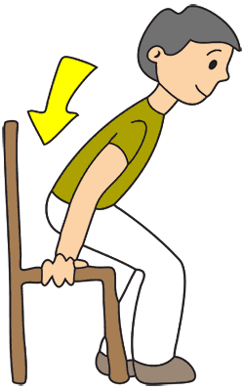
- Match the instructions with the picture.
A. Open your book.
B. Close the door.
C. Stand up.
D. Give me the pencil.
E. Turn around.
F. Open the door.
G. Sit down.
H. Open the window.

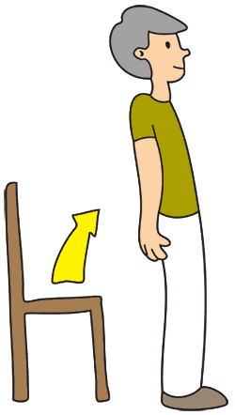
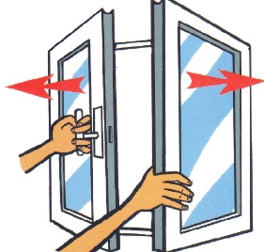

…………………………….
English Language Teacher

