………….. – ………….. EDUCATIONAL YEAR
………………………………………. PRIMARY SCHOOL
4TH GRADE 1ST TERM 1ST EXAM
Duration: 40 minutes
Name-Surname:……………………………………… Class:…………… Number:………

- Write the numbers in words. (10*2=20 points)
1 2 3 4 5
6 7 8 9 10

__________ __________ __________ __________ __________
__________ __________ __________ __________ __________

- Write the numbers. (10*2=20 points)
A) Eleven ............................... F) Forty-six ...........................
B) Fourteen ............................... G) Thirty-nine ...........................
C) Seventeen ............................... H) Twenty-two ...........................
D) Twenty ............................... I) Forty-three ...........................
E) Thirty-five ….........................… J) Fifty ...........................

- Match the countries with the nationalities. (7*2=14 points)
***NATIONALITY***
Spanish
British
Turkish
Chinese
Italian
French
German

***COUNTRY***
Turkey
France
Germany
Italy
Spain
China
Britain

- Match the English sentences with the Turkish meanings. (7*2=14 points)
(……) Listen to your teacher, please.
(……) Turn on the light, please.
(……) Clean the board, please.
(……) Go out, please.
(……) Open the window, please.
(……) Come in, please.
(……) Don’t fight, please.

A. Tahtayı sil, lütfen.
B. Dışarı çık, lütfen.
C. Kavga etme, lütfen.
D. Pencereyi aç, lütfen.
E. İçeri gir, lütfen.
F. Öğretmenini dinle, lütfen.
G. Işığı aç, lütfen.

- Complete the compass with the directions. (4*3=12 Points)
_____________
NORTH
SOUTH
EAST
WEST

_____________
_____________

_____________

- Match the questions with the answers. (5*2=10 Points)
1. I am Turkish.
2. I am ten years old.
3. Yes, you may.
4. My name is Zeynep.
5. I am from Turkey.
A. May I open the window?
B. Where are you from?
C. What is your name?
D. What nationality are you?
E. How old are you?

(5*2=10 Points)
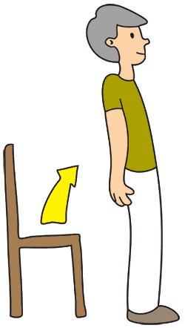
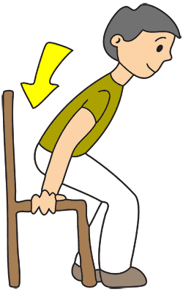
- Match the instructions with the picture.
A. Open your book.
B. Sit down.
C. Turn around.
D. Open the door.
E. Stand up.

……………………………..
English Language Teacher

