………. – ………. EDUCATIONAL YEAR
…………………………………… PRIMARY SCHOOL
4TH GRADE 1ST TERM 1ST EXAM
Duration: 40 minutes
Name-Surname:……………………………………… Class:…………… Number:………
- Write the numbers in words. (10*2=20 points)
1 2 3 4 5
6 7 8 9 10

__________ __________ __________ __________ __________
__________ __________ __________ __________ __________

- Write the numbers. (8*2=16 points)
A) Fourteen ............................... E) Twenty-two ...........................
B) Twenty ............................... F) Thirty-nine ...........................
C) Thirty-five ............................... G) Forty-three ...........................
D) Forty-eight ............................... H) Fifty ...........................

- Match the countries with the nationalities. (6*2=12 points)
***NATIONALITY***
Spanish
Turkish
Chinese
Italian
French
German

***COUNTRY***
Turkey
France
Germany
Italy
Spain
China

- Match the countries with the flags. (5*2=10 points)
A. Japan B. Turkey C. Germany D. The USA E. China

- Complete the compass with the directions. (4*2=8 Points)
_____________
NORTH
SOUTH
EAST
WEST

_____________
_____________

_____________

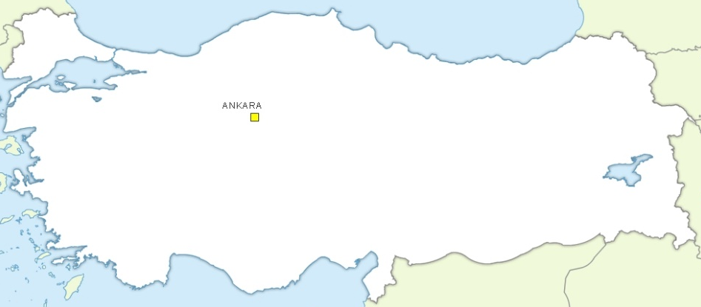
- Look at the Turkey map and complete the sentences. (7*2=14 Points)
- Antalya is in the __________ of Turkey.
- Çanakkale is in the __________ of Turkey.
- Sinop is in the __________ of Turkey.
- Mersin is in the __________ of Turkey.
- Ağrı is in the __________ of Turkey.
- İzmir is in the __________ of Turkey.
- Bitlis is in the __________ of Turkey.
SİNOP
BİTLİS
ÇANAKKALE
MERSİN
AĞRI
ANTALYA

İZMİR

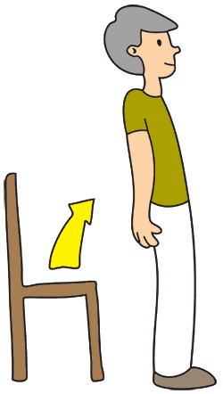
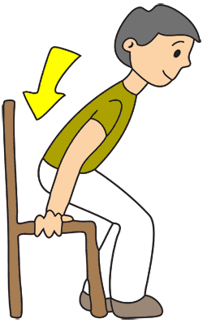
- Match the instructions with the picture. (6*2=12 Points)
A. Open your book.
B. Sit down.
C. Raise your hand.
D. Open the door.
E. Stand up.
F. Be quiet.

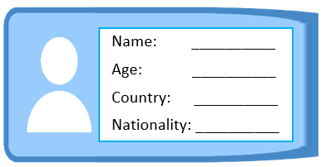
- Fill in the ID card according to speech bubble. (4*2=8 points)
…………………………..
English Language Teacher
Hello, my name is Fred. I’m eleven years old. I’m from Germany. I’m German.

