…………… – …………. EDUCATIONAL YEAR
……………………………………………… PRIMARY SCHOOL
4TH GRADE 1ST TERM 2ND EXAM
Duration: 40 minutes
Name-Surname:……………………………………… Class:…………… Number:………
- Aşağıda İngilizce yazılışları verilen sayıları rakam halleriyle eşleştiriniz. (10*2 = 20 Points)
_____. 11 _____. 50
_____. 32 _____. 12
_____. 27 _____. 36
_____. 19 _____. 29
_____. 41 _____. 8
A. Twenty seven F. Eleven
B. Forty one G. Twenty nine
C. Eight H. Thirty two
D. Thirty six I. Twelve
E. Fifty J. Nineteen

- Match the questions with the answers. (5*3 = 15 Points)
Where are you from? |  | No, he isn’t.
Where is Ağrı? |  | Yes, you may.
What is your name? |  | It is in the East.
Is he Turkish? |  | I’m from Turkey.
May I clean the board? |  | My name is Görkem.

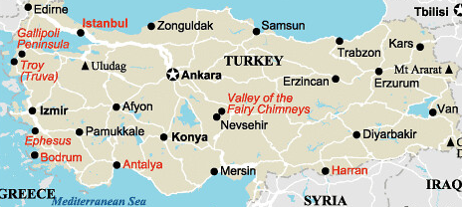
- Look at the map and write your sentences. Where are these cities? (4*2 = 8 Points)
East
West
North
South
- İzmir is in the ___________________.
- Mersin is in the ___________________.
- Van is in the ___________________.
- Samsun is in the _____________________.

- Fill in the blanks with “can” ve “can’t”. (6*2 = 12 Points)
- I _______________ play with ball.
- I _____________ watch cartoons.
- I ______________ ride a bike.
- I________________ fly a kite.
- I _______________ dance.
- I _______________ play tennis.

- Match the pictures with the sentences. (10*3 = 30 Points)
A. She can carry a bag.
B. She can play drum.
C. He can run fast.
D. She can read a book.
E. He can swim.
F. He can climb a tree.
G. She can play piano.
H. He can drive a car.
I. He can take a photograph.
J. He can play guitar.
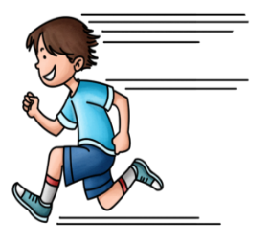
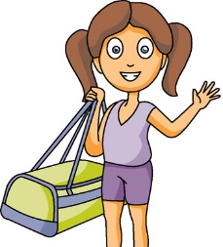

- Fill in the blanks with my – your – his – her . (5*3 = 15 Points)
- She is Molly. These are _________________ pencils.
- You are a teacher. This is _________________ book.
- He is Pam. That is _________________ school bag.
- I am Frank. Those are ________________ kites.
- She is Lisa. This is _________________ piano.

……………………………………
English Language Teacher

