**……………. - ………….. EDUCATIONAL YEAR**

**…………………………………………………….. PRIMARY SCHOOL**

**4TH GRADE 2ND TERM**  **1STEXAM**

Duration: 40 minutes

Name-Surname:……………………………………… Class:…………… Number:………

1. **Kutucuktaki kelime gruplarını aşağıdaki resimlerle eşleştiriniz. (6*3=18 points)**

**A.** climb a tree **B.** cook **C.** ride a bike **D.** ride a horse **E.** play basketball **F.** swim **G.** drive a car

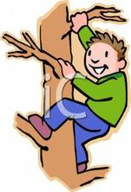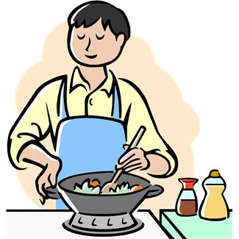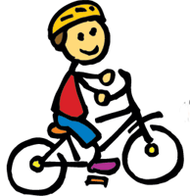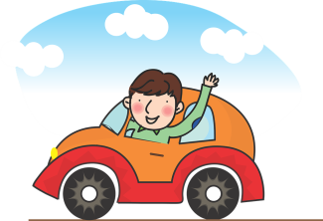

1. **Aşağıdaki boşlukları “can” ve “can’t” ile doldurunuz. (6*2=12 points)**

* She ___________ cook. ☺
* He ___________ play volleyball. ☹
* I ___________ play chess. ☹
* They ___________ ride a bike. ☺
* You ___________ drive a car. ☹
* We ___________ swim. ☺

1. **Kutucuktaki kelime gruplarını aşağıdaki resimlerle eşleştiriniz. (4*3=12 points)**

*Good afternoon *Good evening *Good morning *Good night



1. **Saatin kaç olduğunu yan taraftaki ipuçlarından yararlanarak yazınız. (4*3=12 points)**

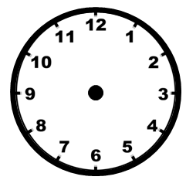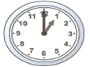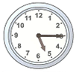

* one o’clock
* five-fifteen
* four-fifty
* one-ten

**It is** ________________________________________.

**It is** ________________________________________.

**It is** _______________________________________.

**It is** _______________________________________.

1. **Renkleri karıştırarak yeni bir renk elde ediniz. (4*4=16 points)**

**A.** Mix **red** and **yellow**, you get __________.

**B.** Mix **blue** and **yellow**, you get __________.

**C.** Mix **blue** and **red**, you get __________.

**D.** Mix **black** and **white**, you get __________.

**6. Aşağıdaki cümleleri resimlere göre kutucuktaki kelimelerle doldurunuz. 6*5=30 points)**

**A.** in **B.** next to **C.** between **D.** behind **E.** in front of **F.** on

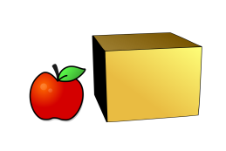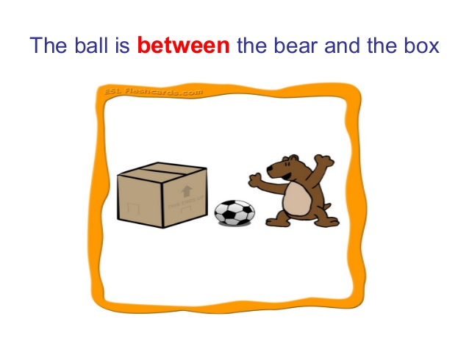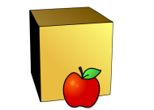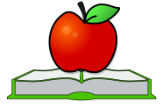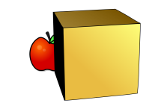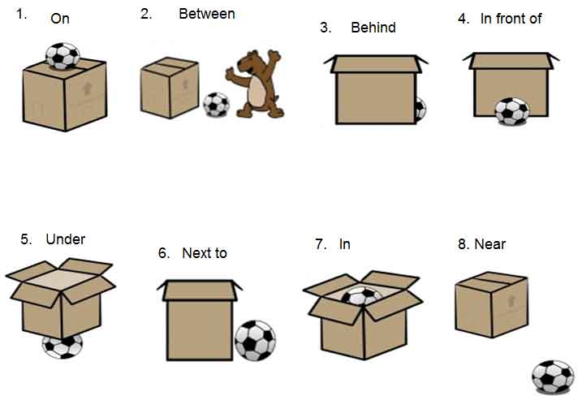

GOOD LUCK ☺

The apple is __________ the box.

The apple is __________ the box and the bear.

The apple is __________ the box.

***……………………………………..***

***English Language Teacher***

The dog is __________ the box.

The apple is __________ the book.

The apple is __________ the box.