**…………… - ………….. EDUCATIONAL YEAR**

**…………………………………………………….. PRIMARY SCHOOL**

**4TH GRADE 2ND TERM**  **2ND EXAM**

Duration: 40 minutes

Name-Surname:……………………………………… Class:…………… Number:………

1. **Resimlerle kelimeleri eşleştiriniz. (9*2 = 18 Points)**

**A**. Hat **B.** Sunglasses **C.** Dress **D.** Scarf **E.** Skirt **F.** Jacket **G.** Trousers **H.** Shoes **I.** T-shirt

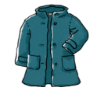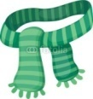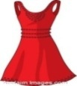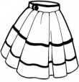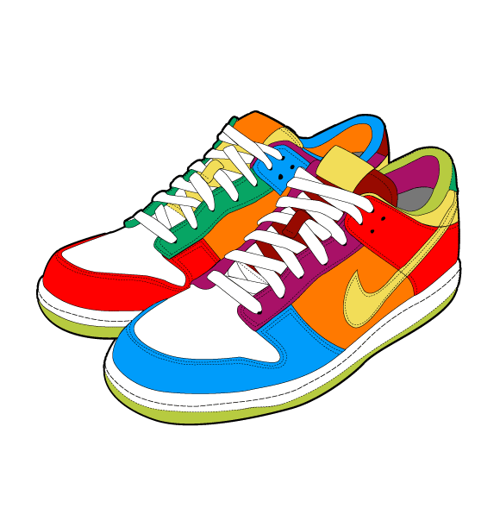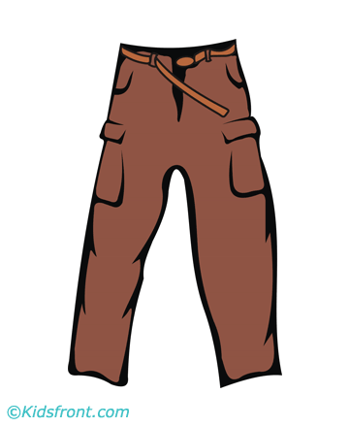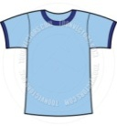

1. **Ayları mevsimlere göre yerleştiriniz. (12*2 = 24 Points)**

**\***January **\***February **\***March **\***April **\***May **\***June **\***July **\***August **\***September **\***October **\***November **\***December



**WINTER**

**______________**

**______________**

**______________**

**AUTUMN**

**______________**

**______________**

**______________**

**SUMMER**

**______________**

**______________**

**______________**

**SPRING**

**______________**

**______________**

**______________**

1. 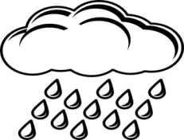**Hava durumuyla ilgili doğru seçeneği işaretleyiniz. (6*2 = 12 Points)**

|  |  |  |  |  |  |
| --- | --- | --- | --- | --- | --- |
| http://images.clipartpanda.com/rain-clipart-black-and-white-clipart-raincloud-black-white-512x512-8ab3.pnghttp://thumbs.dreamstime.com/z/sun-logo-14595574.jpg | http://thumbs.dreamstime.com/z/sun-logo-14595574.jpg | http://www.clker.com/cliparts/7/P/f/u/5/e/snowing-md.png | http://images.clipartpanda.com/clouds-clip-art-RcGx8e7cL.png | **cool thermometer.jpg** | hot termometre.jpg |

it is rainy it is cold it is foggy it is cloudy it is cold it is rainy

it is windy it is sunny it is snowy it is sunny it is windy it is hot

1. **Mesleklerle resimleri eşleştiriniz. (10*2 = 20 Points)**

**A.** Doctor **B.** Farmer  **C.** Policeman **D.** Fireman **E.** Engineer **F.** Cook **G.** Teacher  **H.** Vet **I.** Pilot **J.** Student

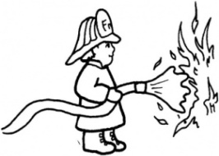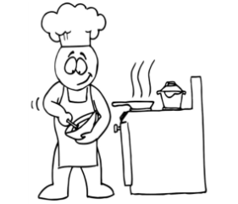[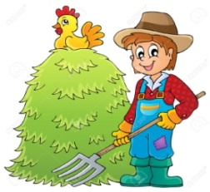](https://www.google.com.tr/url?sa=i&rct=j&q=&esrc=s&frm=1&source=images&cd=&cad=rja&uact=8&ved=0ahUKEwj93seYo-7MAhVJuxQKHexODOoQjRwIBw&url=https://www.123rf.com/photo_22867102_farmer-theme-image-1--eps10-vector-illustration.html&bvm=bv.122448493,d.bGg&psig=AFQjCNGqMP039buLfSCWSeLMj1ijSg39Kg&ust=1464026825190325)[](http://www.google.com.tr/url?sa=i&rct=j&q=&esrc=s&frm=1&source=images&cd=&cad=rja&uact=8&ved=0ahUKEwiXqcvaoO7MAhULtRQKHSH4CRMQjRwIBw&url=http://www.clipartpanda.com/categories/policeman-clip-art-free&bvm=bv.122448493,d.bGg&psig=AFQjCNHT_Z8rW4KzT1ZyQFh4S8JRTKUF5g&ust=1464026065477986)[](http://www.google.com.tr/url?sa=i&rct=j&q=&esrc=s&frm=1&source=images&cd=&cad=rja&uact=8&ved=0ahUKEwiMhPD5pe7MAhXCtxQKHfB-COoQjRwIBw&url=http://clipartfreefor.com/files/8/140024.html&bvm=bv.122448493,d.bGg&psig=AFQjCNGDgONpZeAHI4o3eA-4urhkXJAKzg&ust=1464027549939256)

[](http://www.google.com.tr/url?sa=i&rct=j&q=&esrc=s&frm=1&source=images&cd=&cad=rja&uact=8&ved=0ahUKEwj7-5_gnu7MAhUHkRQKHSq-AY0QjRwIBw&url=http://science-all.com/doctor-clipart.html&bvm=bv.122448493,d.bGg&psig=AFQjCNH_OGWM1_mLk2Z_qLmjB05tF6XfIw&ust=1464025555323664)[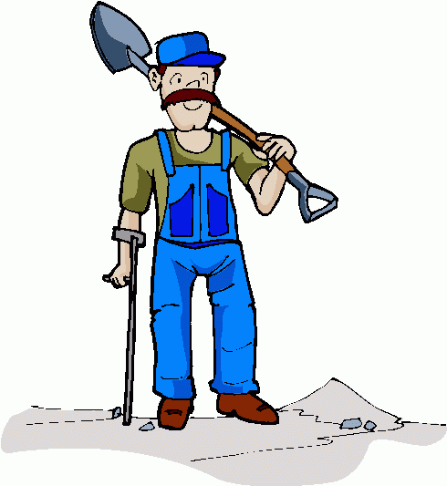](http://www.google.com.tr/url?sa=i&rct=j&q=&esrc=s&frm=1&source=images&cd=&cad=rja&uact=8&ved=0ahUKEwjwy5P1pO7MAhVTGhQKHSTnAZAQjRwIBw&url=http://cliparts.co/free-clip-art-construction-worker&bvm=bv.122448493,d.bGg&psig=AFQjCNFljL7doa6WgFk8h9QbKEnXjGUcSg&ust=1464027287875297)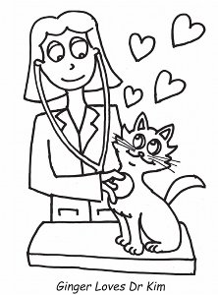[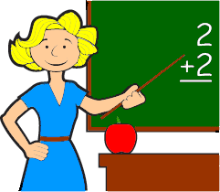](http://www.google.com.tr/url?sa=i&rct=j&q=&esrc=s&frm=1&source=images&cd=&cad=rja&uact=8&ved=0ahUKEwjXzofAo-7MAhXIbxQKHQ5CD8MQjRwIBw&url=http://www.clipartpanda.com/categories/teacher-clip-art&bvm=bv.122448493,d.bGg&psig=AFQjCNETh5DB7B2r7kirYHDGAY0ACWDQwA&ust=1464026931150990)

1. **“Fırça kutunun neresindedir?” Boşlukları doldurunuz. (6*2 = 12 Points)**

**in - on - under - behind - in front of – next to**

|  |  |  |
| --- | --- | --- |
| 1- in front of  …………………………………………… | 2- near  …………………………………………… | 3- behind  …………………………………………… |
| 4- in  ………………………………………… | 5- under  …………………………………………… | 6- on  ………………………………………… |

1. **Saatleri okunuşlarıyla eşleştiriniz. (7*2 = 14 Points)**

|  |
| --- |
| 1. It is three o’clock. **5.** It is eleven - thirty. 2. It is six – twenty five **6.** It is five - forty. 3. It is eight - fifty. **7.** It is ten - fifteen. 4. It is five - five. |



GOOD LUCK ☺

GOOD LUCK ☺

***……………………………………..***

***English Language Teacher***