……..-……… EDUCATIONAL YEAR
……………………. SECONDARY SCHOOL
5TH GRADE 1ST TERM 1ST EXAM
Duration: 40 minutes
Name-Surname:……………………………………… Class:…………… Number:………

- Fill in the blanks. (5*5=25 points)
COUNTRY | NATIONALITY
Turkey | …………………………
………………………… | Italian
Japan | …………………………
………………………… | German
France | …………………………

- Complete the missing letters. (13*1=13 points)

COUNTRY | LANGUAGE
China | C_in_s_
Russia | R_s_ia_
England | En_l_s_
Turkey | T_rk_sh
Spain | S_an_sh

- Read the speech bubble and complete the paragraph with the words. (5*3=15 points)

study
like
don’t like
from
speak

Hello, I’m Tom. I’m …………… England. I …………… at Spring Secondary School. I …………… English and Spanish. I …………… P.E because I’m good at playing football. I …………… science because I don’t enjoy doing experiments.
- Match the questions with the answers. (5*3=15 points)
- Where are you from? _____ 1) I am Spanish.
- How many languages do you speak?____ 2) I am nine years old.
- What nationality are you?_____ 3) My name is Adriana.
- How old are you? ____ 4) I am from Spain.
- What is your name?_____ 5) Two. English and Spanish.

- Match the classes with their names. (8*3=24 points)

- Social Studies | - Science | - Maths | - Turkish
- Physical Education | - Music | - English | - Art

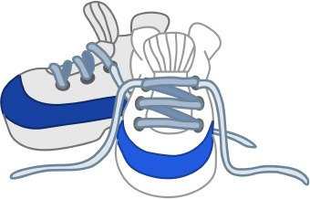
……………………. | ……………………. | ……………………. | …………………….
……………………. | ……………………. | ……………………. | …………………….

- Match the places with their names. (4*2=8 points)

a. bakery | b. post office | c. library | d. hospital | e. cinema

GOOD LUCK
………………………………..
English Language Teacher

