**………-……… EDUCATIONAL YEAR**

**…………………………… SECONDARY SCHOOL**

**5TH GRADE** **1STTERM 1ST EXAM**

Duration: 40 minutes

Name-Surname:……………………………………… Class:…………… Number:………

1. **Fill in the blanks in chart according to speech bubble. (5*2=10 points)**

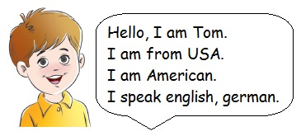

|  |  |
| --- | --- |
| **(2) Name** | …………………………………….. |
| **(2) Country** | ……………………………………. |
| **(2) Nationality** | ……………………………………. |
| **(4) Languages** | ………………….. /………………… |

1. **Complete the missing letters. (14*1=14 points)**

|  |  |
| --- | --- |
| **COUNTRY** | **LANGUAGE** |
| India | I_di_n |
| Canada | C_n_d_a_ |
| England | En_l_s_ |
| Turkey | T_rk_s_ |
| Spain | S_an_sh |

1. **Match the places with their names. (7*2=14 points)**

**a.** Post Office **b.** Library **c.** Mosque **d.** Toy shop **e.** Cinema **f.** Playground **g.** Cafe

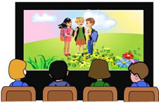





1. **Match the classes with their names. (7*3=21 points)**

|  |  |  |  |
| --- | --- | --- | --- |
| 1. Information Technology | 1. Science | 1. Maths | 1. Art |
| 1. Physical Education | 1. Music | 1. English |

|  |  |  |  |
| --- | --- | --- | --- |
|  |  |  |  |
|  |  |  |

**5. Look at the pictures and where is the dog? (7*3=21 points)**

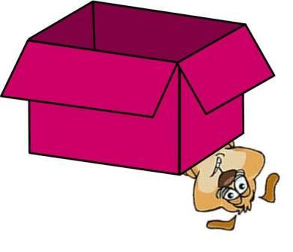   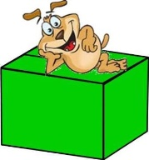  

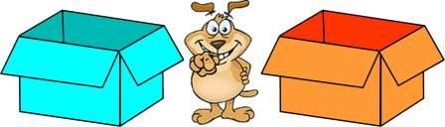



**6. Match the questions with the answers. (5*2=10 points)**

**\***Where are you from? _____ **a)** No, I am not.

**\***How many languages do you speak?____ **b)** I am eleven years old.

**\***Are you from Turkey?_____ **c)** My name is Sevda.

**\***How old are you? ____ **d)** I am from Canada.

**\***What is your name?_____ **e)** Two. English and Spanish.

**7. Fill in the blanks with “like” and “don’t like”. (5*2=10 points)**

**a)** I _______________ Maths and English lessons.☹  
**b)** I _____________ playing basketball.☺  
**c)** I ______________ watching TV.☺  
**d)** I________________ solving Maths problems.☹  
**e)** I _______________ singing songs.☹

**……………………………..**

**English Language Teacher**

**A.** between **B.** on **C.** in **D.** next to **E.** in front of **F.** under **G.** behind