………… – ……….. EDUCATIONAL YEAR
………………………………….. SECONDARY SCHOOL
5TH GRADE 1STTERM 1ST EXAM
Duration: 40 minutes
Name-Surname:……………………………………… Class:…………… Number:………
- Fill in the blanks. (5*2=10 points)

COUNTRY | NATIONALITY
Turkey | …………………………
………………………… | Italian
Japan | …………………………
………………………… | German
France | …………………………

- Complete the missing letters. (13*1=13 points)
COUNTRY | LANGUAGE
China | C_in_s_
Russia | R_s_ia_
England | En_l_s_
Turkey | T_rk_sh
Spain | S_an_sh

- Fill in the blanks in chart according to speech bubble. (5*2=10 points)
(2) Name | ……………………………………..
(2) Country | …………………………………….
(2) Nationality | …………………………………….
(4) Languages | ………………….. /…………………

- Match the questions with the answers. (5*2=10 points)
- Where are you from? _____ 1) I am Turkish.
- How many languages do you speak?____ 2) I am ten years old.
- What nationality are you?_____ 3) My name is Selin.
- How old are you? ____ 4) I am from Turkey.
- What is your name?_____ 5) Two. English and German.
- Match the classes with their names. (7*2=14 points)
A. Social Studies B. Science C. Information Technology (I.T) D. Maths
E. Art F. Music G. Physical Education (P.E)

A. between B. on C. in D. next to E. in front of F. under G. behind
6. Look at the pictures and where is the dog? (7*2=14 points)

7. Fill in the blanks with “like” and “don’t like”. (5*2=10 points)
a) I _______________ Maths and English lessons.
b) I _____________ playing basketball.
c) I ______________ watching TV.
d) I________________ solving Maths problems.
e) I _______________ singing songs.

8. Match the phrases with the directions.
(3*2=6 Points)

A. Turn right B. Turn left
C. Go straight ahead

10. Match the places with their names. (3*2=6 Points)

9. Look at the map and “How can I go to the car park?”.
(7 Points)

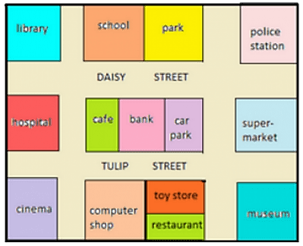
………………………………….
English Language Teacher
A. Library B. Hospital C. Bakery
………………………………………………………………………………………………………………………………………………………………………………………………………

