**………. – ………. EDUCATIONAL YEAR**

**……………………………….. SECONDARY SCHOOL**

**5TH GRADE** **1STTERM 1ST EXAM**

Duration: 40 minutes

Name-Surname:……………………………………… Class:…………… Number:………

1. **Fill in the blanks. (5*2=10 points)**

|  |  |
| --- | --- |
| **COUNTRY** | **NATIONALITY** |
| Turkey | ………………………… |
| ………………………… | Italian |
| Japan | ………………………… |
| ………………………… | German |
| France | ………………………… |

1. **Fill in the blanks in chart according to speech bubble. (5*2=10 points)**

|  |  |
| --- | --- |
| **Name** | ……………………………………………….. |
| **Country** | …………………………………….…………. |
| **Nationality** | ……………………………………….………. |
| **Languages** | ……………….…….. /……………….…… |



Hello, my name is Tim. I’m from the USA. I’m American. I speak English and German.

1. **Match the questions with the answers. (5*3=15 points)**
2. Where are you from? _____ 1) I like maths, science and music.
3. How many languages do you speak?____ 2) I study at Atatürk Secondary School.
4. What are your favourite classes?_____ 3) My name is Ezgi.
5. Where do you study? ____ 4) I am from Turkey.
6. What is your name?_____ 5) Two. Turkish and English.
7. **Match the classes with their names. (7*2=14 points)**

**A.** Social Studies **B.** Science **C.** Information Technology (I.T) **D.** Maths

**E.** Art **F.** Music **G.** Physical Education (P.E)

**metin, küçük resim içeren bir resim

Açıklama otomatik olarak oluşturuldu****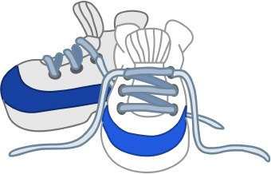**

1. **Look at the picture below and complete the sentences with prepositions of place. (5*3=15 points)**

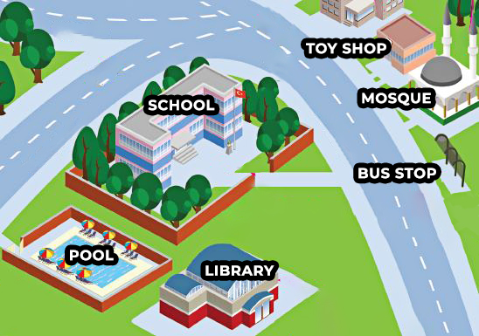

**A.** The pool is _______________ the library.

**B.** The bus stop is _______________ the school.

**C.** The mosque is _______________ the bus stop and the toy shop.

**D.** The toy shop is _______________ the mosque.

**E.** The trees are _______________ the school.

1. ******Match the places with their names. (6*2=12 points)**



**A.** Book shop

**B.** Hospital

**C.** Toy shop

**D.** Pharmacy

**E.** Bakery

**F.** Post office

**8. Match the phrases with the directions.(3*2=6 Points)**

**  **

**7. Match the countries with the flags. (4*3=12 points)**

**A.** Brazil **B.** Turkey **C.** Germany **D.** China





**metin, beyaz tahta içeren bir resim

Açıklama otomatik olarak oluşturuldu9. Fill in the missing days of the week. (3*2=6 points)**

**………………………………**

**English Language Teacher**

Monday **__________** Wednesday Thursday **__________** Saturday **__________**