**………-…….. EDUCATIONAL YEAR**

**…………………………………. SECONDARY SCHOOL**

**5TH GRADE** **1ST TERM 2ND EXAM**

Duration: 40 minutes

Name-Surname:……………………………………… Class:…………… Number:………

**1. Fill in the blanks in chart according to speech bubble. (5*2=10 points)**

|  |  |
| --- | --- |
| **(2) Name** | …………………………………….. |
| **(2) Country** | ……………………………………. |
| **(2) Nationality** | ……………………………………. |
| **(4) Languages** | ………………….. /………………… |



**2.** **Match the classes with their names. (7*3=21 points)**

|  |  |  |
| --- | --- | --- |
| 1. Science | 1. Maths | 1. Turkish |
| 1. Physical Education | 1. Music | 1. English | 1. Art |

|  |  |  |
| --- | --- | --- |
|  |  |  |
| **…………………….** | **…………………….** | **…………………….** | **…………………….** |
|  |  |  |  |
| **…………………….** | **…………………….** | **…………………….** | **…………………….** |

**3.** **Match the places with their names. (7*3=21 points)**

**a.** Post Office **b.** Library **c.** Mosque **d.** Hospital **e.** Cinema **f.** Zoo **g.** Cafe



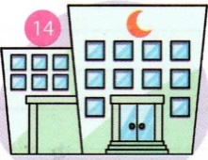



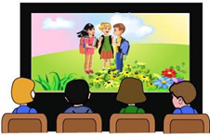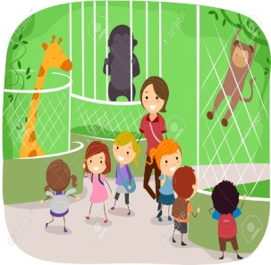

**5. Look at the picturs and where is the dog? (7*3=21 points)**



 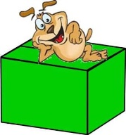  

  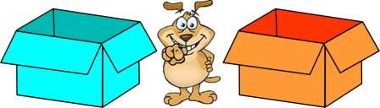

**4. Fill in the blanks with “like” and “don’t like”.**

**(5*3=15 points)**

**a)** I _______________ Maths and English lessons.☹  
**b)** I _____________ playing basketball.☺  
**c)** I ______________ watching TV.☺  
**d)** I________________ solving Maths problems.☹  
**e)** I _______________ singing songs.☹

**A)** brush teeth **B)** go fishing **C)** camping **D)** do homework **E)** play computer games **F)** skip rope

**6. Match the pictures with the words.**

**(6*2=12 points)**

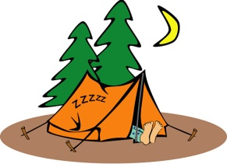  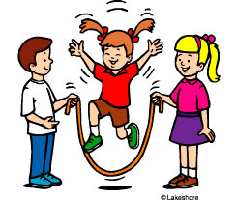

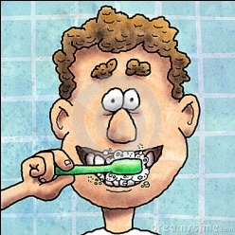 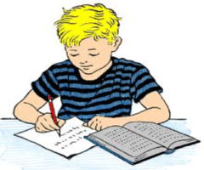 



***…………………………………….***

***English Language Teacher***