**…………….. – …………… EDUCATIONAL YEAR**

**……………………………………………… SECONDARY SCHOOL**

**5TH GRADE** **1ST TERM 2ND EXAM**

Duration: 40 minutes

Name-Surname:……………………………………… Class:…………… Number:………

1. **Match the words with the correct pictures. (8*2=16 points)**

**A.** play soccer **B.** do origami **C.** do magic **D.** sing songs

**E.** play hide and seek **F.** play hopscotch **G.** do puzzles **H.** play blind man’s buff

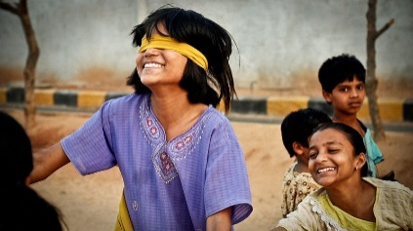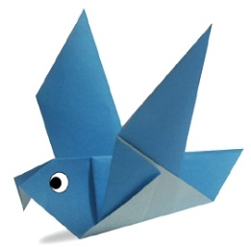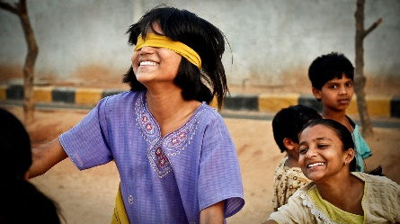

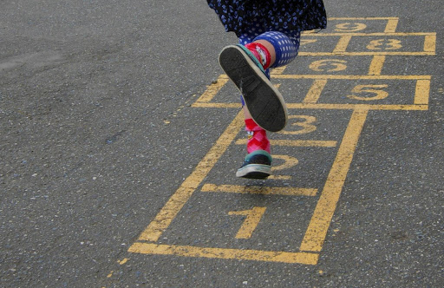

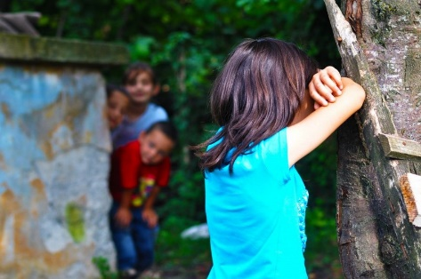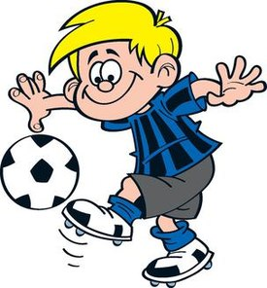

1. **Fill in blanks with the correct words. (6*3=18 points)**

**A.** Turkey

**B.** playing tennis (+)

**C.** Sema

**D.** playing chess (-)

**E.** riding a bike (-)

**F.** dancing (+)



**My name is** …………..…….. . **I’m from** …………..…….. .

**I like** ……………………….…… **and** ………………….…….….. .

**I don’t like** ……….………..….. **and** ………….…..……..… .

**3. The hospital is …………………… the restaurant and pharmacy. (9 points)**

**A.** opposite **B.** next to

**C.** between **D.** behind

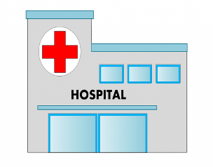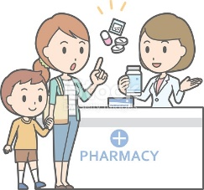



1. 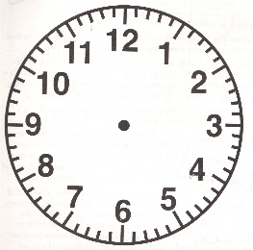**Match the time with the clocks. (6*3=18 points)**



**🡪** It is four o’clock. _____

**🡪** It is ten past eleven. _____

**🡪** It is quarter to one. _____

**🡪** It is half past seven. _____

**🡪** It is twenty to three. _____

**🡪** It is quarter past ten. _____



1. 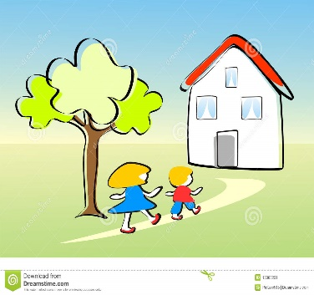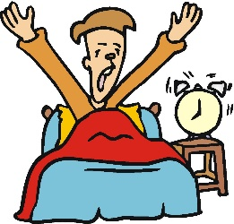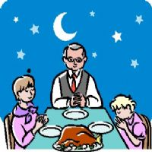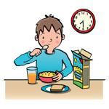**Number the pictures in the correct order. (7*3=21 points)**

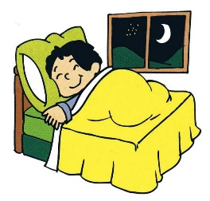

go to bed

come back home

get up early

have dinner

have breakfast

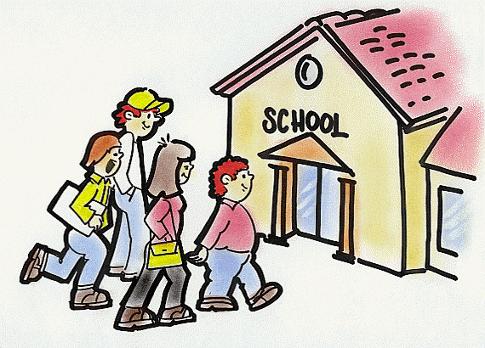

arrive at school

brush teeth

1. 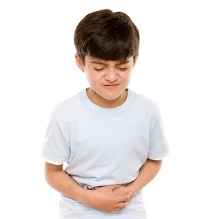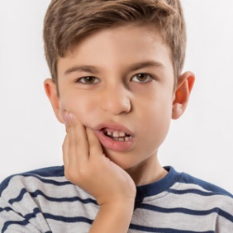**Match the children with their health problems. (6*3=18 points)**

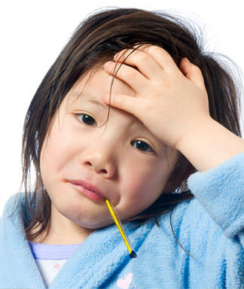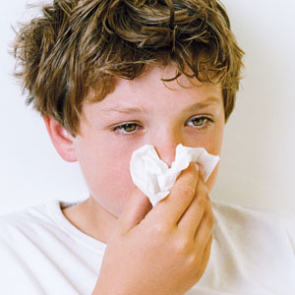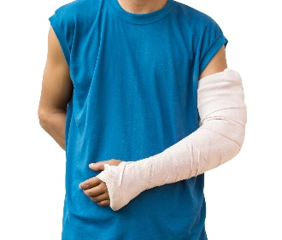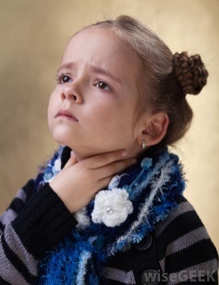



**………………………………………..**

**English Language Teacher**

**A.** broken arm  **B.** sore throat **C.** stomachache **D.** fever **E.** toothache  **F.** runny nose