**…………….. - ……………. EDUCATIONAL YEAR**

**………………………………………………….. SECONDARY SCHOOL**

**5TH GRADE 2ND TERM 1ST EXAM**

Duration: 40 minutes

**Name-Surname:……………………………………… Class:…………… Number:………**

1. **Match the activities with the pictures. (10*2=20 points)**

**a.** get on the bus **b.** do homework **c.** have breakfast **d.** go to school **e.** brush teeth

**f.** play basketball **g.** sleep **h.** play football **i.** get dressed **j.** play computer games

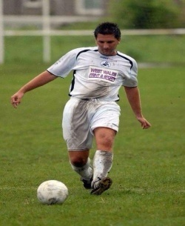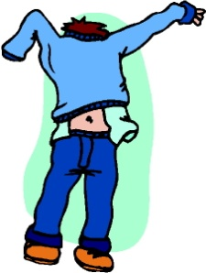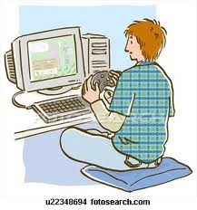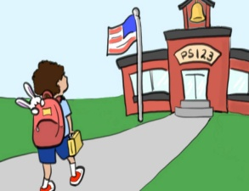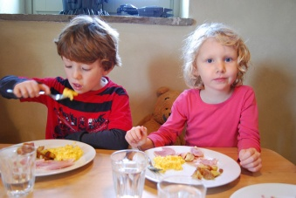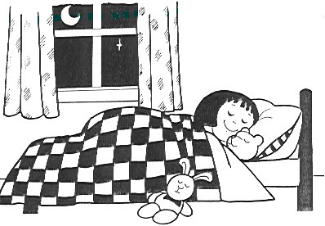

1. **Draw the time shown on each clock. (6*4=24 points)**

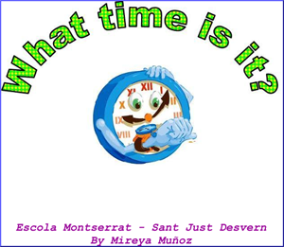**A** **B** 

1. It is half past three.
2. It is two o’clock.
3. It is quarter past four.
4. It is quarter to ten.
5. It is one o’clock.
6. It is half past nine.

**C** **D**

**E** **F** 

1. 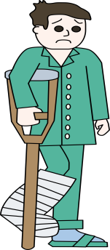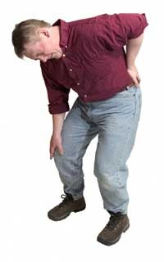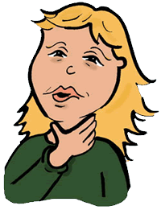**Match the illnesses with the pictures. (7*3=21 points)**

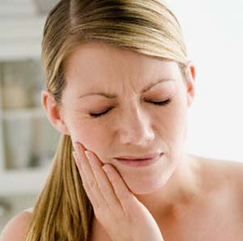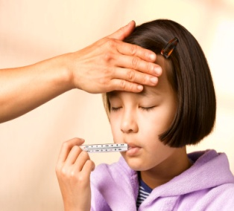

**A.** toothache **B.** backache **C.** broken arm **D.** sore throat  **E.** stomachache **F.** broken leg **G.** fever

1. **Look at the notes and make sentences with “*should* ” – “*shouldn’t* ”**. **(7*5=35 points)**

**You** ………………………………………………………………………………………………….

**You** ………………………………………………………………………………………………….

**You** ………………………………………………………………………………………………….

**You** ………………………………………………………………………………………………….

**You** ………………………………………………………………………………………………….

**You** ………………………………………………………………………………………………….

**You** ………………………………………………………………………………………………….

**See a doctor.**

**Don’t eat chocolate.**

**Wash your hands.**

**Have breakfast.**

**Brush your teeth.**

**Don’t drink cold water.**

**Don’t drink coke.**



***………………………………………***

***English Language Teacher***