…………. – ….……… EDUCATIONAL YEAR
…………………………………………… SECONDARY SCHOOL
5TH GRADE 2ND TERM 1ST EXAM
Duration: 40 minutes
Name-Surname:……………………………………… Class:…………… Number:………
- Group the words. (10*2=20 Points)
Science Fiction – Frightening – Boring – Horror – Animation – Action – Funny – Comedy – Exciting – Interesting

Types of Movies | I think the movie is …

- Complete the table. (4*2= 8 Points)
-09.00 p.m
-Horror
-The Ghost House
-City Cinema
Name Of The Movie
Type Of The Movie
Time
Place

- Match the words with the pictures. (8*2= 16 points)
A. Party Hats B. Birthday Cake C. Balloons D. Confetti
E. Cookies F. Beverages G. Music Band H. Clown

- Complete the missing words. (4*2= 8 points)

- at 7 oclock

- Sheila

- on the terrace of our house

- on Sunday, 5th July

The Date: ______________
The Time: ______________
The Place: _____________
By ___________

- Order the letters and write the months. (12*2= 24 points)
P R I A L
…………………
A J U R N A Y
…………………..
U A G S U T
………………….
E P S M B E R E T
…………………..
H A C M R
…………………
R E F U R B A Y
…………………..

M E R E B D C E
…………………..
A M Y
………………..
Y L J U
………………..
O V N E R B E M
…………………..
U J E N
………………
O T C E R B O
…………………..

- Answer these questions. (2*6= 12 points)
- Allen: Do you like volleyball?
Bob: ______________.
- Yes, he does.
- No, I can’t.
- Yes, I do.
- No, she doesn’t.
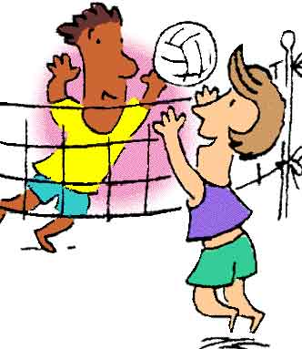
- I like _____________ .
- jogging
- swimming
- skiing
- sailing

- Write two words for each verb. (6*2= 12 points)
soccer bike chess
gymnastics puzzle horse

- Do _________________ / ______________

- Ride a ______________ / ______________

- Play _______________ / _______________

GOOD LUCK ! 😊
…………………………………….
English Language Teacher

