……….. – ………. EDUCATIONAL YEAR
……………………………………………………… SECONDARY SCHOOL
5TH GRADE 2ND TERM 2ND EXAM
Duration: 40 minutes
Name-Surname:……………………………………… Class:…………… Number:………
- Write two words for each verb. (6*2= 12 points)
soccer bike chess
gymnastics puzzle horse

- Do _________________ / ______________

- Ride a ______________ / ______________

- Play _______________ / _______________
- Match the animals with the pictures. (8*2 = 16 Points)
A. Duck B. Rabbit C. Squirrel D. Kitten E. Stork F. Puppy G. Frog H. Butterfly
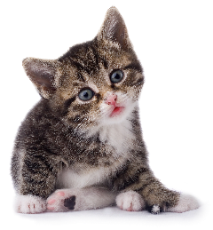
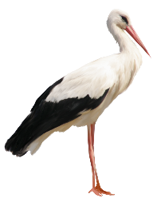
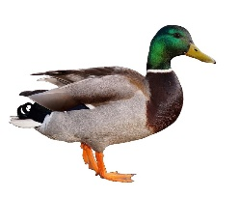
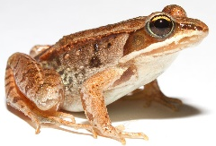
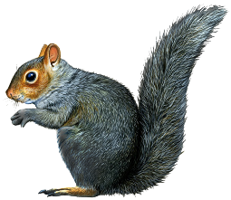
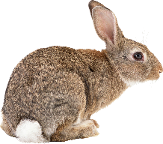
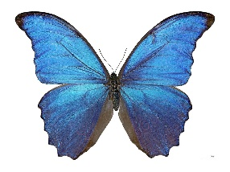

- Write the words in the correct order. (6*3 = 18 Points)
- playing / ball / are / the kittens / with / the / blue .
______________________________________________

- lake / the duck / swimming / in / the / is / green .
______________________________________________

- sleeping / table / the puppies / the / under / are .
______________________________________________

- is / garden / in / feeding / a young man / the birds / the .
______________________________________________

- in / the vet / horse / is / the clinic / examining / brown / a .
______________________________________________

- street / money / is / my / for / animals / donating / father .
______________________________________________

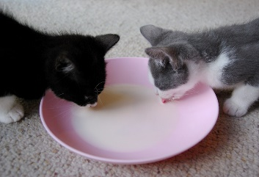
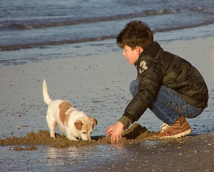
- Look at the pictures and complete the dialogues with “CAN I …?” (3*3 = 9 Points)
Sam: _______________________________?
His Father: Yes, you can.
donate / money / to the animal shelter
feed / the kittens
Susan: ________________________?
Zack: Yes, you can.
Kaan: _______________________?
His mum: Of course, you can.
play / with the puppy

- Read the speech bubbles and write the names of the festivals. (3*3 = 9 Points)
We celebrate it on 30th August. We decorate the streets with turkish flags and watch the parade.
We celebrate it on 4th July. American people decorate their houses and watch fireworks at night.
We celebrate it on 23rd April. We decorate our class with turkish flags.
A. Independence Day B. Victory Day C. Children’s Day

- Write the numbers. (10*3 = 30 Points)
Three hundred and sixty five: ________
Seven hundred and twenty nine: ________
One hundred and eighty four: ________
Five hundred and thirty: ________
Nine hundred and seven: ________
256: ____________________________________
987: ____________________________________
431: ____________________________________
185: ____________________________________
503: ____________________________________

- Answer the questions. ( 2*3 = 6 Points)
- I like ……………….. .

- ice skating
- skiing
- roller skating
- skateboarding

- “I need ten …………… (mumlar), a ……………. (palyaço) and some ……….. (parti şapkaları).”

A. guests - party hats - gifts
B. candles - clown - party hats
C. drinks - presents - candles
D. invitation cards - cake - games
…………………………………….
English Language Teacher

