……….. – ………. EDUCATIONAL YEAR
……………………………………………………… SECONDARY SCHOOL
5TH GRADE 2ND TERM 2ND EXAM
Duration: 40 minutes
Name-Surname:……………………………………… Class:…………… Number:………
- Complete the blanks correctly. (3*2=6 Points)
Monday ____________ Wednesday _____________ Friday ___________ Sunday
- Put the months of the year order correctly. (12*2=24 Points)
February – April – September – August – January – March – October – July – May – December – June - November

1. 5. 9.
2. 6. 10.
3. 7. 11.
4. 8. 12.

- Match the seasons with the pictures. (4*2=8 Points)
❷❷
❶
A. Winter ______
B. Autumn ______
C. Summer ______
D. Spring ______

❹
❸

- Label the fitness activities. (8*2=16 Points)
A. jogging B. camping C. cycling D. trekking E. working out F. swimming G. fishing H. dancing
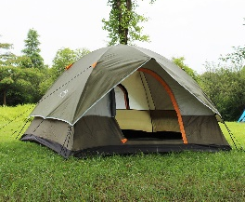
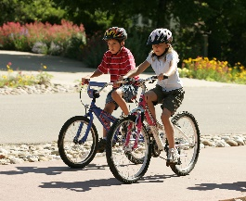

- Complete the table. (8*2=16 Points)

A. basketball B. dancing C. swimming D. football E. fishing F. hiking G. handball H. tennis
Play + ……………
Go + ……………

- Read the sentences and complete the table with ✓ and X . (5*2=10 Points)
 | Tim | Sarah | Jane
fishing
cycling
volleyball
golf
A. Sarah likes playing volleyball.
B. Tim dislikes going fishing.
C. Jane can play golf.
D. Tim can’t play volleyball.
E. Sarah likes cycling.
- Complete the table. (6*2=12 Points)
- Yes, of course.
- Let’s play football.
- I’m sorry, I can’t play handball.
- No, thanks.
- How about dancing?
- That sounds great.

Refusing
Accepting
Suggesting

- Match the animals with the pictures. (4*2 = 8 Points)
A. Parrot B. Rabbit C. Dog D. Cat

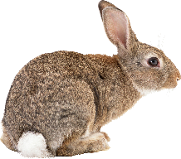

…………………………………….
English Language Teacher

