…………. – …………. EDUCATIONAL YEAR
……………………………………… SECONDARY SCHOOL
6TH GRADE 1ST TERM 1ST EXAM
Duration: 40 minutes
Name-Surname:……………………………………… Class:…………… Number:………

- Match the words with the pictures. (one extra) (6*2=12 points)
A. take  a nap | B. wash  the dishes | C. have  breakfast | D. visit  grandparents | E. take care of the flowers | F. wash the clothes | G. leave  home
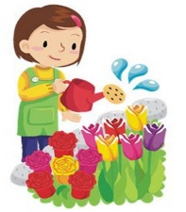
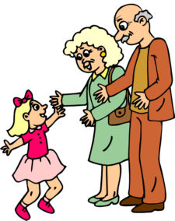
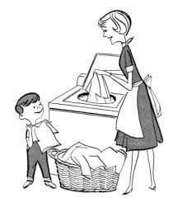
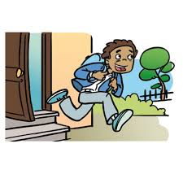
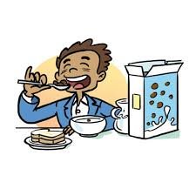

- Match the times with the clocks. (6*3=18 points)
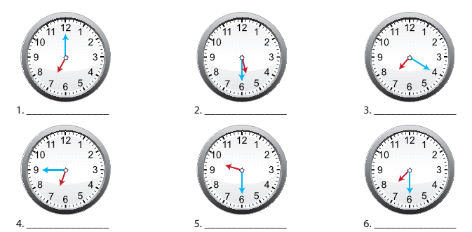

a) It is seven o’clock. d) It is quarter to seven.
b) It is twenty past seven. e) It is half past five.
c) It is half past seven. f) It is haf past nine.

- Write the names of the months. (6*2=12 Points)
The 11th month of the year: _________________ The 9th month of the year: _________________
The 12th month of the year: _________________ The 2nd month of the year: _________________
The 9th month of the year: __________________ The 6th month of the year: _________________

- Put a tick (✓) for correct option. (3 Points)
A B C
 | A | B | C
 | lightning | sunny | cloudy
 | sunny | stormy | rainy
 | windy | sunny | rainy
 | foggy | thunder | partly cloudy

- Look at the chart and make sentences about what the people are doing? (5*4=20 points)
You And Your Friends | Activity
a.) You | skip rope
b.) Oliver | fly a kite
c.) Mary | ride a bicycle
d.) Nilly and Sam | have lunch
e.) Kevin | rollerblade

- ______________________________________________
- ______________________________________________
- ______________________________________________
- ______________________________________________
- ______________________________________________
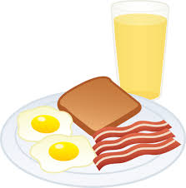
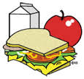
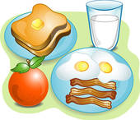
- Match the speech bubbles with the pictures. (5*3=15 points)
A. B. C. D. E.

Hi! My name is Mark. I like eating eggs, sausages and toast at berakfast. My favourite drink is orange juice.

Hello! I’m Sally. My favourite food is pancake at breakfast and I like tea..

Hello! My name is Tim. I love eating cereal with milk at breakfast.

Hi! I’m Anna. I eat an apple and toast at breakfast. I like milk.

Hello! I’m Clark. I always eat toast, eggs, sausages and an orange at breakfast. I drink a glass of milk every morning.

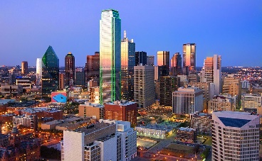
- Compare the downtown and the uptown by using keywords. (5*4= 20 Points)
crowded
big
expensive
green
noisy
1. _________________________________________________
2. _________________________________________________
3. _________________________________________________
4. _________________________________________________
5. _________________________________________________
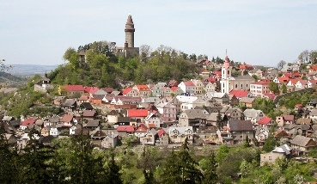
GOOD LUCK!
………………………………..
English Language Teacher

