**…………. – ………….. EDUCATIONAL YEAR**

**…………………………………………… SECONDARY SCHOOL**

**6TH GRADE** **1ST TERM 1ST EXAM**

Duration: 40 minutes

Name-Surname:……………………………………… Class:…………… Number:………

1. 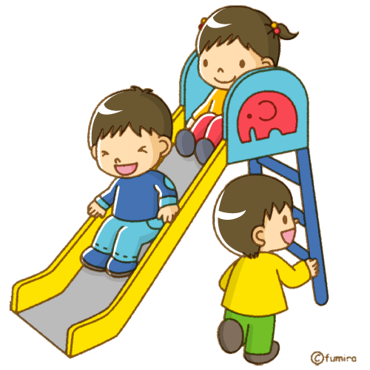**Match the words with the pictures.** **(6*2=12 points)**

**A).** have dinner **B.** feed the dog **C.** finish homework **D.** rest **E.** run errands **F.** play with friends

1. **Draw the time shown on each clock. (6*2=12 points)**

**\*It’s half past one. / *It’s quarter to five. / *It’s nine o’clock. / *It’s quarter past two. / *It’s ten past four. / *It’s five to one.**

1. **Complete the blanks correctly. (4*3=12 points)**

**Weekdays****:** Monday …………… Wednesday …………… ……………

**Weekends:** …………… Sunday

1. **Categorize the food and drink items. (14*1=14 points)**

croissant cucumber sausage butter salami cheese pancake

milk cereal honey chips muffin olives orange juice

**JUNK FOOD**

**NUTRITIOUS FOOD**

1. **Read the paragraph and write true (T) or false (F). (5*3=15 Points)**

**A.** His town is cheaper than her city. **(……)**

**B.** She thinks city is more beautiful than town. **(..…)**

**C.** Jessica has a big flat and garden. **(……)**

**D.** His town is greener than her city. **(……)**

**E.** His town is noisier than her city. **(……)**

Hi, my name is Jessica and my friend’s name is Bob. I live in a big city but Bob lives in small town. My flat is bigger than his house. Bu he has a big garden. My city is more crowded than his town. But his town is quiter than my city. My city is busier and more expensive. But his town is cheaper and greener. I think town is more beautiful than city.



1. 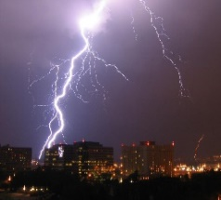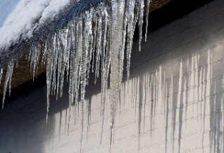**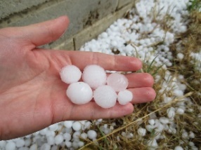Match the weather words with the pictures. (8*2=16 Points)**

**A.** *Rainy*

**B.** *Foggy*

**C.** *Partly cloudy*

**D.** *Hailing*

**E.** *Lightning*

**F.** *Freezing*

**G.** *Sunny*

**H.** *Windy*

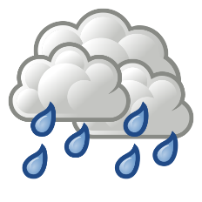

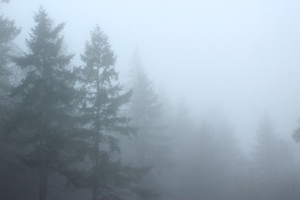

**8. Choose the correct option. (7 Points)**

I. Because I don’t like it.

II. No, I don’t.

III. Do you eat jam at breakfast?

IV. Why don’t you eat it?

**What is the correct order of the dialogue?**

**A).** I – II – IV – III

**B).** III – I – II – IV

**C).** III – I – IV – II

**D).** III – II – IV – I

**7. Look at the pictures and write your sentences. What are they doing? (3*4=12 Points)**



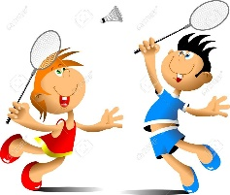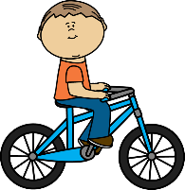

**……………………………….**

**English Language Teacher**

**GOOD LUCK! 😊**

Tina and Sam________________________.

Brad ______________________________.

Alex ________________________________.