**……..-…….. EDUCATIONAL YEAR**

**………………………………… SECONDARY SCHOOL**

**6TH GRADE** **1ST TERM 1ST EXAM**

Duration: 40 minutes

Name-Surname:……………………………………… Class:…………… Number:………

1. **Match the words with the pictures.** **(6\*3=18 points)**

|  |  |  |  |  |  |  |
| --- | --- | --- | --- | --- | --- | --- |
| take a nap | have a shower | have breakfast | visit grandparents | learn folk dance | help mother | leave home |

|  |  |  |
| --- | --- | --- |
| C:\Users\USER\Desktop\leave home.jpg | C:\Users\USER\Desktop\images (1).jpg | C:\Users\USER\Desktop\have_a_shower.jpg |
| **a.)** | **b.)** | **c.)** |
| C:\Users\USER\Desktop\take a nap.jpg | C:\Users\USER\Desktop\grandparentss.jpg | C:\Users\USER\Desktop\indir.jpg |
| **d.)** | **e.)** | **f.)** |

1. **Draw the time shown on each clock. (6\*2=12 points)**

     

**\*It’s half past one. \*It’s quarter to five. \*It’s nine o’clock. \*It’s quarter past two. \*It’s ten past four. \*It’s five to one.**

1. **Complete the blanks correctly. (4\*3=12 points)**

**Weekdays****:** Monday …………… Wednesday …………… ……………

**Weekends:** …………… Sunday

1. **Make sentences about what you do on different days. (5\*4=20 points)**

|  |  |  |  |  |
| --- | --- | --- | --- | --- |
|  | **Activity** | **Time** | **Day** | **Adverbs of Frequency** |
| **a.)** | do homework | 03:30 p.m | thursday | usually |
| **b.)** | go to school | 08:00 a.m | monday | always |
| **c.)** | brush teeth | 07:20 a.m | wednesday | **-** |
| **d.)** | have lunch | 12:15 p.m | **-** | sometimes |
| **e.)** | play soccer | 04:00 p.m | sunday | often |

**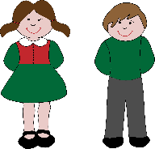**

**YOU**

1. **\_\_\_\_\_\_\_\_\_\_\_\_\_\_\_\_\_\_\_\_\_\_\_\_\_\_\_\_\_\_\_\_\_\_\_\_\_\_\_\_\_\_\_\_\_\_**
2. **\_\_\_\_\_\_\_\_\_\_\_\_\_\_\_\_\_\_\_\_\_\_\_\_\_\_\_\_\_\_\_\_\_\_\_\_\_\_\_\_\_\_\_\_\_\_**
3. **\_\_\_\_\_\_\_\_\_\_\_\_\_\_\_\_\_\_\_\_\_\_\_\_\_\_\_\_\_\_\_\_\_\_\_\_\_\_\_\_\_\_\_\_\_\_**
4. **\_\_\_\_\_\_\_\_\_\_\_\_\_\_\_\_\_\_\_\_\_\_\_\_\_\_\_\_\_\_\_\_\_\_\_\_\_\_\_\_\_\_\_\_\_\_**
5. **\_\_\_\_\_\_\_\_\_\_\_\_\_\_\_\_\_\_\_\_\_\_\_\_\_\_\_\_\_\_\_\_\_\_\_\_\_\_\_\_\_\_\_\_\_\_**
6. **Match the times with the clocks. (6\*3=18 points)**

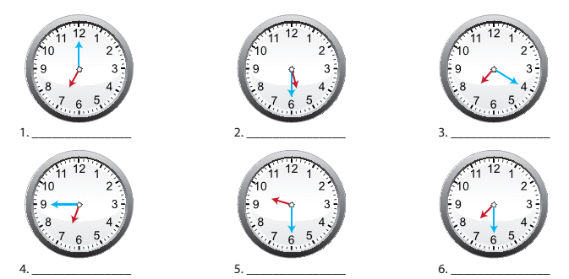

**a)** It is seven o’clock. **d)** It is quarter to seven.

**b)** It is twenty past seven. **e)** It is half past five.

**c)** It is half past seven. **f)** It is haf past nine.

1. **Look at the pictures. Write the names of the food and drink items. (10\*2=20 point)**

|  |  |  |  |  |  |  |  |  |  |
| --- | --- | --- | --- | --- | --- | --- | --- | --- | --- |
| 1. cheese | 1. olives | 1. honey | 1. egg | 1. croissant | 1. tea | 1. cereals | 1. bagel | 1. bread | **j)** jam |

|  |  |  |  |  |
| --- | --- | --- | --- | --- |
|  | C:\Users\tuğba\Desktop\peynir2.jpg | http://t2.gstatic.com/images?q=tbn:ANd9GcQ--SqAyte2mn4MtrJsJAYjbiSoGYlKWslR8vicQtk_VnTv4i01 |  | http://ec.l.thumbs.canstockphoto.com/canstock20343716.jpg |
| **……………………………** | **………………………** | **………………………** | **…………………….** | **…………………………** |
| C:\Users\tuğba\Desktop\raspberry-jam-04.jpg | ANd9GcSJkWQCF3zW4YySvDxF5vCQD6XxZfBWAAuU9jBAU-9op3wTIp3x |  |  |  |
| **………………………** | **………………………** | **………………………** | **………………………** | **………………………** |

**…………………………………**

**GOOD LUCK! 😊**

**English Language Teacher**