**………. – ………. EDUCATIONAL YEAR**

**………………………………….. SECONDARY SCHOOL**

**6TH GRADE** **1ST TERM 1ST EXAM**

Duration: 40 minutes

Name-Surname:……………………………………… Class:…………… Number:………

1. 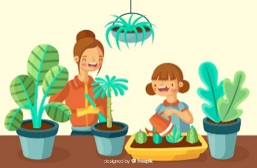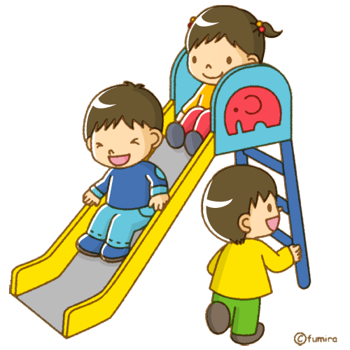**Match the words with the pictures.** **(8*2=16 points)**

**A.** have dinner **B.** take care of the flowers

**C.** do homework **D.** do the ironing

**E.** run errands **F.** play with friends

**G.** get up **H.** take a nap

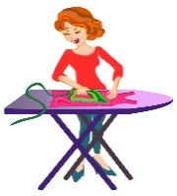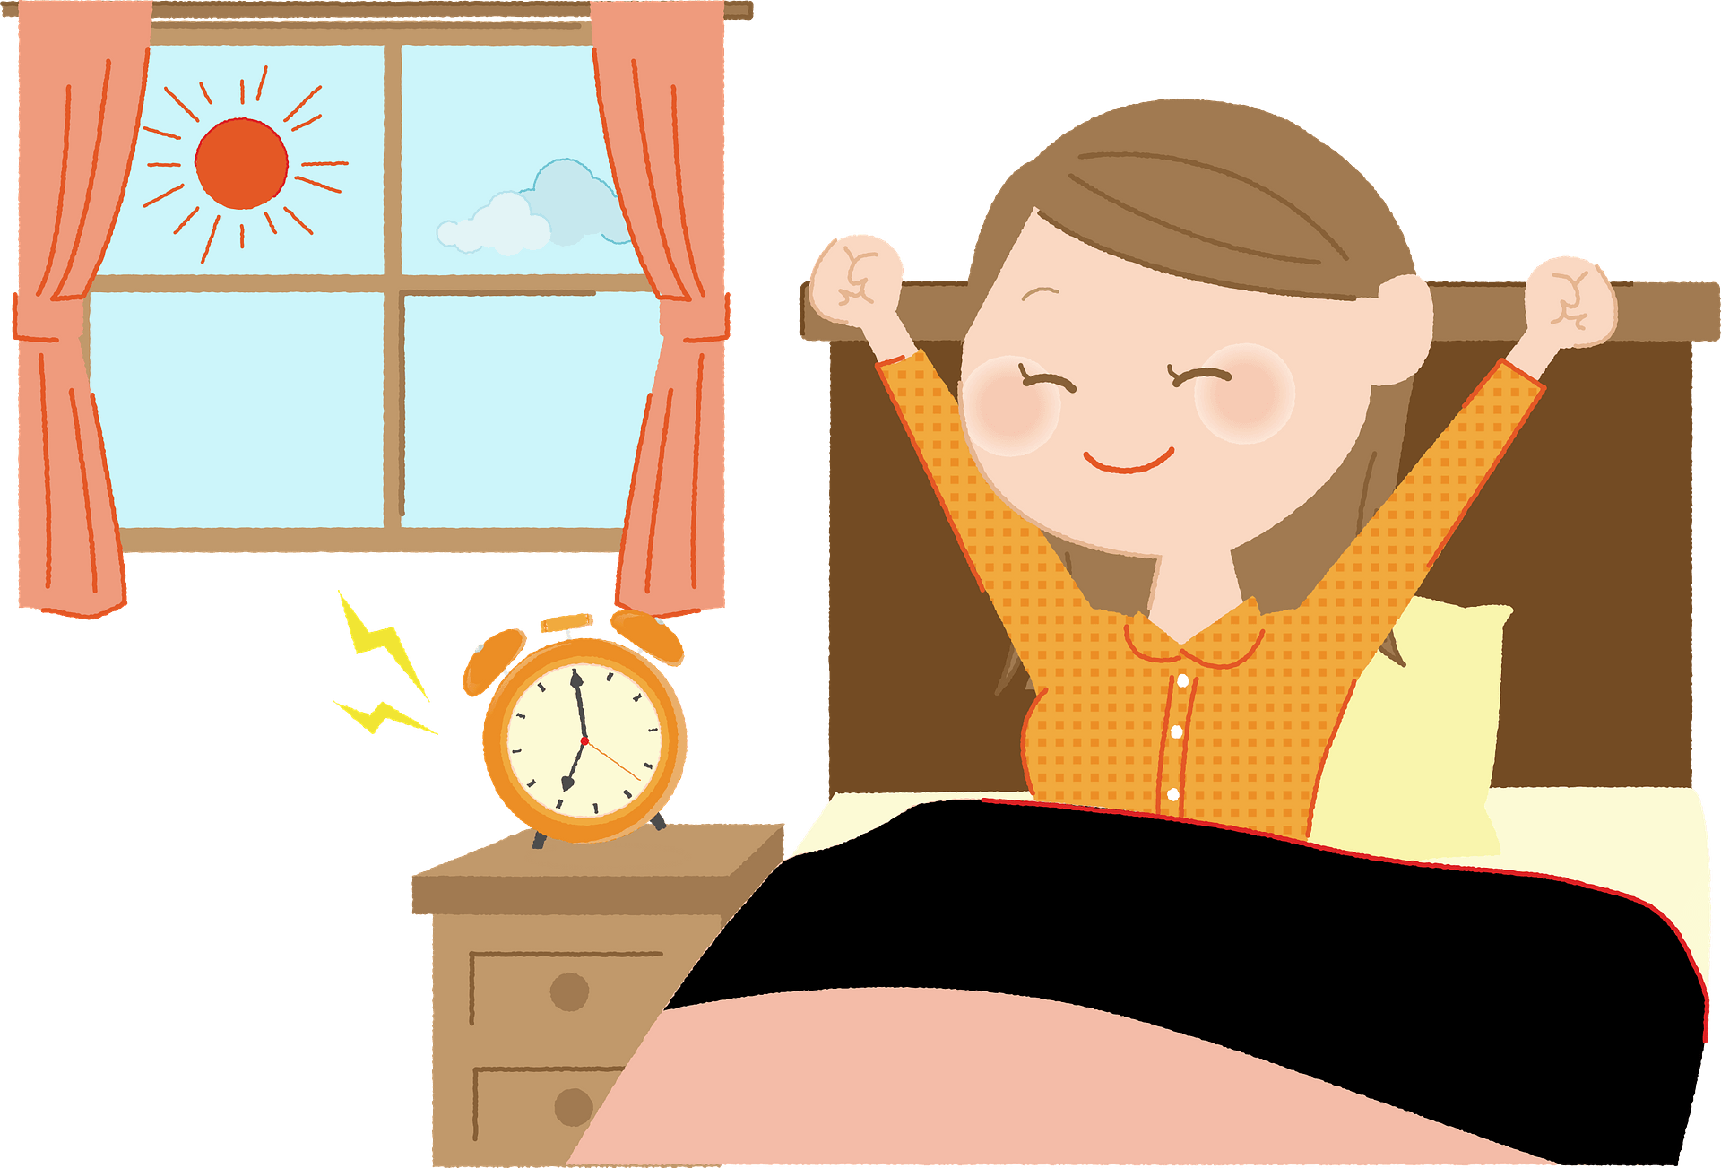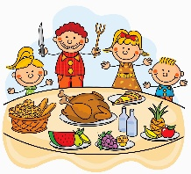

1. **Match the times with the clocks. (6*2=12 points)**

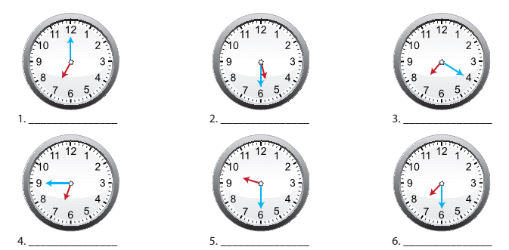metin, saat, duvar, farklı içeren bir resim

Açıklama otomatik olarak oluşturuldu

**a)** It is seven o’clock.

**b)** It is twenty past seven.

**c)** It is half past seven.

**d)** It is quarter to seven.

**e)** It is half past five.

**f)** It is haf past nine.

1. **Draw the time shown on each clock. (6*2=12 points)**

**\*It’s half past one. / *It’s quarter to five. / *It’s nine o’clock. / *It’s quarter past two. / *It’s ten past four. / *It’s five to one.**

1. **Write the names of the months. (6*2=12 Points)**

The 3rd month of the year: _________________ The 5th month of the year: _________________

The 12th month of the year: _________________ The 2nd month of the year: _________________

The 9th month of the year: __________________ The 7th month of the year: _________________

1. **Complete the blanks correctly. (4*2=8 points)**

**Weekdays****:** Monday ………….….... Wednesday …..….…..……… …………….….…

**Weekends:** ……………….. Sunday

1. 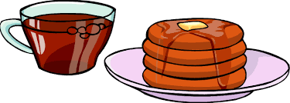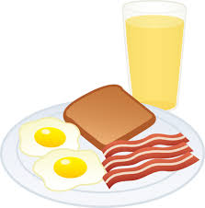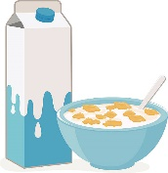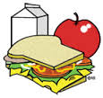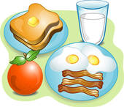 **Match the speech bubbles with the pictures. (5*4=20 points)**

**A. B. C. D. E.**



Hi! My name is Mark. I like eating eggs, sausages and toast at berakfast. My favourite drink is orange juice.

Hello! I’m Sally. My favourite food is pancake at breakfast and I like tea..

Hello! My name is Tim. I love eating cereal with milk at breakfast.

Hi! I’m Anna. I eat an apple and toast at breakfast. I like milk.

Hello! I’m Clark. I always eat toast, eggs, sausages and an orange at breakfast. I drink a glass of milk every morning.

1. **Categorize the food and drink items. (12*1=12 points)**

croissant cucumber sausage tomato salami cheese

egg cereal honey chips muffin olives

**NUTRITIOUS FOOD**

**JUNK FOOD**

1. **Answer the questions below. (2*4=8 points)**

**A.** What do you eat at breakfast?

__________________________________________________________________________________.

**B.** What do you drink at breakfast?

__________________________________________________________________________________.

**metin, beyaz tahta içeren bir resim

Açıklama otomatik olarak oluşturuldu**

**……………………………**

**English Language Teacher**