**………………. – ……………… EDUCATIONAL YEAR**

**……………………………………………….. SECONDARY SCHOOL**

**6TH GRADE** **1ST TERM 2ND EXAM**

Duration: 40 minutes

Name-Surname:……………………………………… Class:…………… Number:………

1. 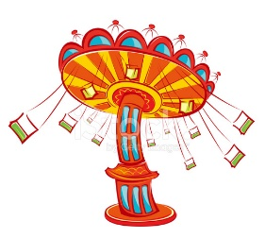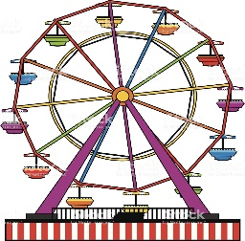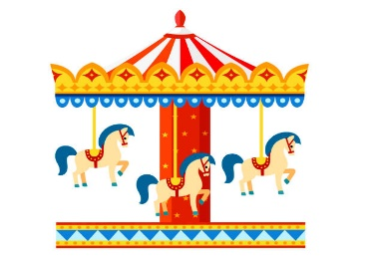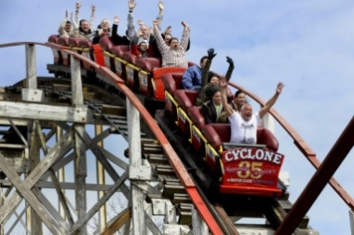**Match the given phrases with the correct picture. (8*2 = 16 Points)**

**A.** Hall of mirrors

**B.** Carousel

**C.** Clown

**D.** Ferris Wheel

**E.** Ghost train

**F.** Bumper cars

**G.** Chairoplane

**H.** Roller coaster

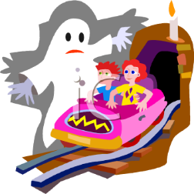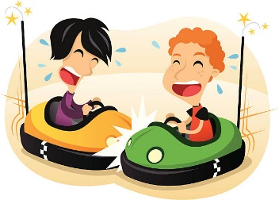

|  |  |  |  |  |
| --- | --- | --- | --- | --- |
|  | **Fairs? – Playgrounds?** | **riding carousel** | **riding ferris wheel** | **playing on the swings** |
| **Hank** | **Fairs👍 Playgrounds👎** | **😊** | **😊** | **☹** |
| **colourful** |
| **Lisa** | **Fairs👎 Playgrounds👍** | **☹** | **☹** | **😊** |
| **interesting** |

1. **Look at the table and complete the sentences. (6*3 = 18 Points)**

Lisa thinks playgrounds ………………………………………... fairs.

She likes ………………………………………………………………………. .

She doesn’t like …………………………………………………………… .

Hank thinks fairs ……………………………………... playgrounds.

He likes ………………………………………………………………………. .

He doesn’t like …………………………………………………………… .

1. **Read the sentences and choose the correct words according to the emoticons. (5*1 = 5 Points)**



I feel **cheerful/angry** because it’s sunny outside.

It’s lighting outside and I feel **moody/ scared**.

I feel **anxious/upset** when the weather is stormy.

I feel **sleepy/frightened** on foggy Autumn days.

I’m **excited/sad** now because it’s cold and rainy outside.



1. 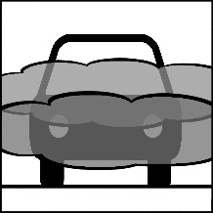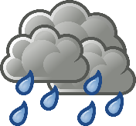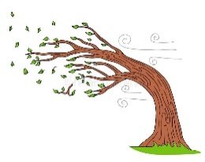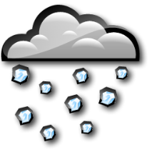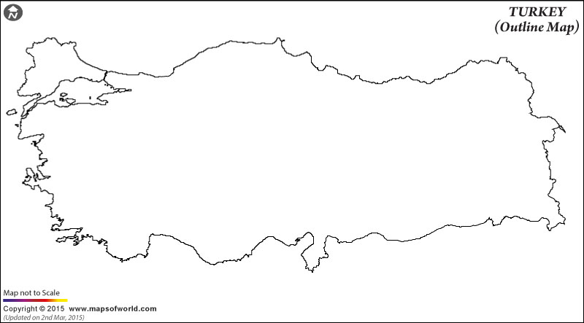**Answer the questions by using the map. (7*4 = 28 Points)**

**A.** What is the weather like in Erzurum? **E.** What is the weather like in İzmir?

_________________________________ . ____________________________________ .

**B.** What is the weather like in Antalya? **F.** What is the weather like in Gaziantep?

_________________________________ . ____________________________________ .

**C.** What is the weather like in Ankara? **G.** What is the weather like in İstanbul?

_________________________________ . ____________________________________ .

**D.** What is the weather like in Samsun?

_________________________________ .

**GAZİANTEP**

**ERZURUM**

**SAMSUN**

**ANKARA**

**ANTALYA**

**İZMİR**

**İSTANBUL**

**6. Complete the sentences with comparative forms. (6*3 = 18 Points)**

* A rabbit is ________________ than a turtle. (fast)
* Antalya is ________________ than Erzurum. (sunny)
* An elephant is _______________ than a cat. (big)
* My English is ______________ than your English. (good)
* İstanbul is ________________ than Ağrı. (crowded)
* Ghost train is ________________ than carousel. (frightening)

**5. Write your sentences. What he is doing now? (3*5 = 15 Points)**

_____________________________ .

__________________________ .

____________________________.

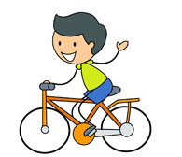

**…………………………………**

**English Language Teacher**