**……..-……… EDUCATIONAL YEAR**

**……………………………… SECONDARY SCHOOL**

**6TH GRADE** **1ST TERM 2ND EXAM**

Duration: 40 minutes

Name-Surname:……………………………………… Class:…………… Number:………

**1.. Match the words with the pictures. (7*3=21 points)**

**A.** wash hands **B.** play the guitar **C.** have a shower **D.** do homework **E.** have breakfast **F.** get on the bus **G.** get up

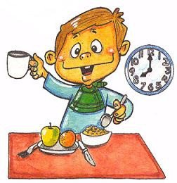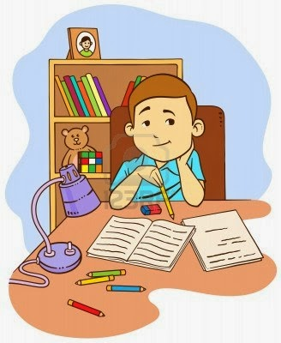



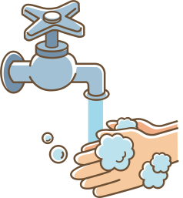

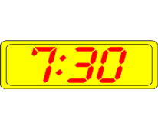**2. Match the time with the clocks. (7*3=21 points)**

___- It is one thirty.

___- It is three forty-five.

___- It is ten thirty-eight.

___- It is twelve forty-seven.

___- It is seven thirty.

___- It is eleven ten.

___- It is seven fifteen.

**a.**

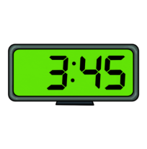

**b.**

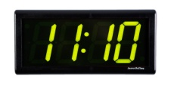

**c.**

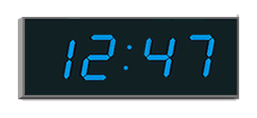

**d.**

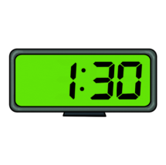

**e.**

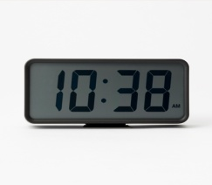

**f.**

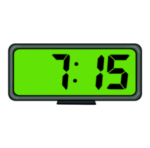

**g.**

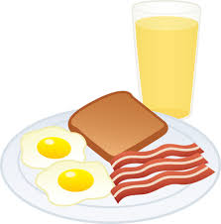**3. Match the speech bubbles with the pictures. (5*4=20 points)**

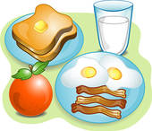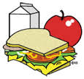**A.. B. C. D. E.**



Hi! My name is Onur. I like eating eggs, sausages and toast at berakfast. My favourite drink is orange juice.

Hi! I’m Emel. I eat an apple and toast at breakfast. I like milk.

Hello! My name is Anıl. I love eating cereal with milk at breakfast.

Hello! I’m Yeşim. My favourite food is pancake at breakfast and I like tea..

Hello! I’m Sedat. I always eat toast, eggs, sausages and an orange at breakfast. I drink a glass of milk every morning.

**6. Fill in the blanks with comparatives. (10*3=30 points)**

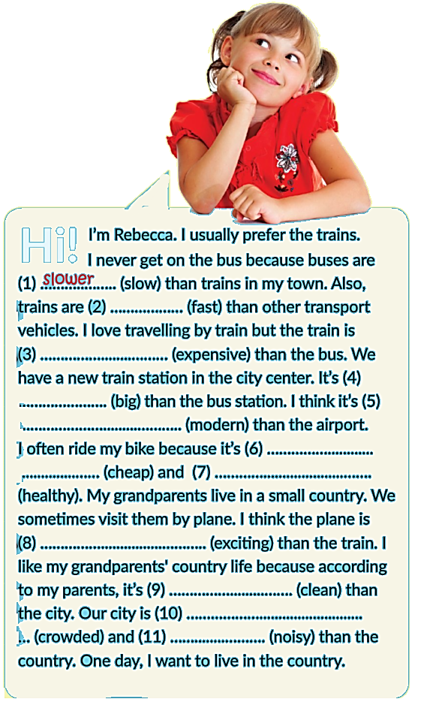

**4. Aşağıdaki hava olaylarının doğru sıralanışı**

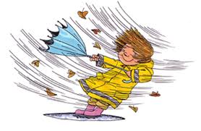**hangi seçenekte verilmiştir? (3 points)**

a) sunny-rainy-windy b) windy-sunny-rainy

c) rainy-sunny-windy d) rainy-windy-sunny

**5. Where is the bank? (3 points)**

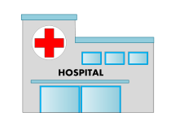

a) It is opposite the hospital.

b) It is behind the school.

c) It is between the school and the hospital.

d) It is in front of the hospital.



***……………………………….***

***English Language Teacher***