………….. - ……….… EDUCATIONAL YEAR
………………….…………………………….. SECONDARY SCHOOL
6TH GRADE 2ND TERM 1ST EXAM
Duration: 40 minutes
Name-Surname:……………………………………… Class:…………… Number:………
- Write the months of the year under the correct seasons. (12*2=24 points)
*January *February *March *April *May *June *July *August *September *October *November *December
SPRING
______________
______________
______________
SUMMER
______________
______________
______________

AUTUMN
______________
______________
______________
WINTER
______________
______________
______________

- Complete the blanks correctly. (4*2=8 points)

Weekdays: Monday …………… …………… Thursday ……………
Weekends: …………… Sunday
- Look at the map and answer the questions about weather conditions. (5*3=15 points)
A. What is the weather like in İstanbul?
It is __________________________.
B. What is the weather like in Ankara?
It is __________________________.
C. What is the weather like in Adana?
It is __________________________.
D. What is the weather like in Trabzon?
It is __________________________.
E. What is the weather like in Kars?
It is __________________________.

Rüzgarlı
Karlı
Yağmurlu
Bulutlu

Güneşli
- Match the pictures with the names of the fun rides. (5*3=15 points)
A. Bumper Cars B. Carousel C. Roller Coaster D. Ferris Wheel E. Chairoplane




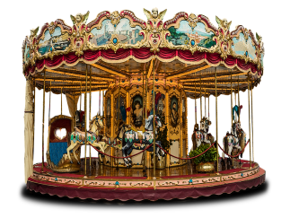
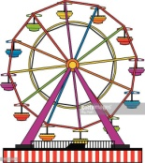

- Write the meanings and past forms of the verbs below. (10*2=20 points)

V1 (Infinitive) | V2 (Past) | Anlam
be
come
do
go
swim

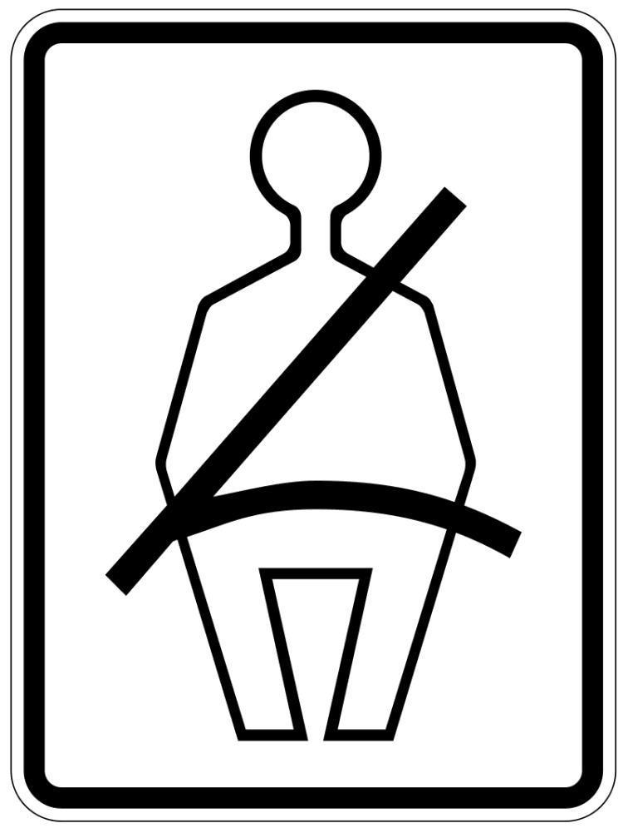
- Match the signs with the sentences. (6*3=18 points)





…….……………………….
English Language Teacher
***Fasten your seat belts. ***No mobile phones. ***For general audiences.
***Don’t take photos. ***For 13 and over. ***Pets not allowed.

