………… – ………… EDUCATIONAL YEAR
…………………………………………….. SECONDARY SCHOOL
7TH GRADE1STTERM 1ST EXAM
Duration: 40 minutes
Name-Surname:……………………………………… Class:…………… Number:………
- Categorize the words. (10*2= 20 Points)
A. handsome B. punctual C. stubborn D. slim E. thoughtful
F. overweight G. tall H. honest I. friendly J. brown eyes

Personality
Appearance

- Complete the sentences with adjectives in the box. (5*2= 10 Points)
honest

punctual

lazy

generous

polite

-My brother doesn’t tell lies. He is ___________.
-Selin has got a lot of money and she helps poor people. she is ___________ .
-My sister always says “thank you”. She is a ___________ person.
-Sevda teacher is never late. She is very ___________.
-My daughter never does his homework. She is ___________.

- Write the comparatives of the adjectives. (6*2= 12 Points)
- Antalya is __________________ (hot) than Ağrı.
- A computer is __________________ (expensive) than radio.
- Milk is __________________ (good) than coffee.
- My cousin is __________________ (slim) than my sister.
- Ünal teacher is __________________ (funny) than me.
- My sister is __________________ (selfish) than my brother.
5. Write the years in words. (3*2=6 points)
1992: ___________________________
2019: ___________________________
2000: ___________________________

- 4. Circle the correct word. (5*2=10 points)
- Timmy wasn’t / weren’t at party last night.
- Alex and Tom was / were in the school garden ten minutes ago.
- Was / Were you in Antalya five years ago?
- I was / were born in Ağrı in 2001.
- We was / were at the theatre yesterday.

- Look at the table and fill in the blanks. (6*2= 12 Points)

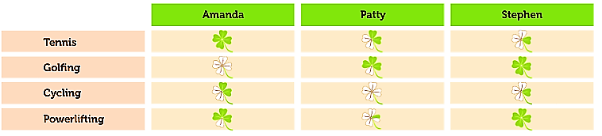

a. Amanda always plays tennis . (play tennis) e. Patty _____________________ . (go cycling)
b. Amanda _____________________ . (go cycling) f. Stephen _____________________ . (play tennis)
c. Amanda _____________________ . (do powerlifting) g. Stephen _____________________ . (play golf)
d. Patty _____________________ . (play golf)

- Write the meanings and past forms of the verbs below. (10*2=20 points)
PRESENT (V1) | PAST (V2) | ANLAM | PRESENT (V1) | PAST (V2) | ANLAM
1. Go |  |  | 6. Hear
2. Swim |  |  | 7. Leave
3. Give |  |  | 8. Know
4. Do |  |  | 9. See
5. Become |  |  | 10. Understand

- Choose the correct options. (2*5=10 Points)
Emma: _________________________?
Jack: Once a week.
What is the best question according to the answer?
A). Do you like indoor sports?
B). Why do you play football?
C). How often do you train?
D). Where do you play volleyball?
City | Yesterday | Today
Antalya | 29 | 34
Ağrı | 11 | 15
İstanbul | 24 | 20

Which one is TRUE?
A). Antalya is colder than İstanbul today.
B). Ağrı was hotter than İstanbul yesterday.
C). İstanbul is colder than Ağrı today.
D). Antalya was hotter than Ağrı yesterday.

……………………………………..
English Language Teacher

