……….. – ………… EDUCATIONAL YEAR
………………………………………… SECONDARY SCHOOL
7TH GRADE1STTERM 1ST EXAM
Duration: 40 minutes
Name-Surname:……………………………………… Class:…………… Number:………
- Write the words in the correct column. (8*2=16 points)
*clumsy *forgetful *outgoing *lazy *hardworking *selfish *generous *honest

POSITIVE FEATURES 😊 | NEGATIVE FEATURES ☹

- Write the comparatives of the adjectives. (6*2= 12 Points)
- Erzurum is __________________ (cold) than İzmir.
- Anna is __________________ (overweight) than her sister.
- Orange juice is __________________ (good) than tea.
- My brother is __________________ (slim) than me.
- My father is __________________ (funny) than my mother.
- Sam is __________________ (outgoing) than Terry.

- Write the past forms of the verbs below. (5*2=10 points)
PRESENT (V1) | PAST (V2)
be
move
win
start
put

- Order the frequency adverbs and write the meanings of them. (5*2=10 points)
 | Frequency Adverbs | Anlam
*****
****
***
**
*

Sometimes
Always
Rarely
Usually
Often

- Fill in the blanks with the past forms the verbs. (10*2=20 points)
Barış MANÇO was extraordinary public figure. He …………..(be) a musician and a programme producer. He was born on January 2,1943 in İstanbul. He …………………(graduate) from Şişli Terakki High School. Then, he ………....(move) to Belgium to study at Royal Academy of Arts. He ……………(come) back to Turkey in 1970. He …………….(get) married to Lale MANÇO in 1978. They……………… (raise) to children. He …………….. (produce) a programme called ‘from 7 to 77 with Barış MANÇO’. It was a family and children oriented programme. He ……………. (found) a group called ‘Kurtalan Ekspres’. He ……………..(win) some awards such as ‘International Culture and Peace Award’ from Japan in 1991 and ‘Highest Honour of Art’ from Japan again in 1995. He ………….(die) on January 31,1999.

- Answer the questions using the the words in brackets. (2*4= 8 Points)
-How often do you play tennis? (twice a day)
________________________________________________________
-How often do you play golf? (never)
________________________________________________________

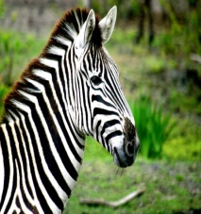
- Match the pictures with the animals. (8*2=16 points)
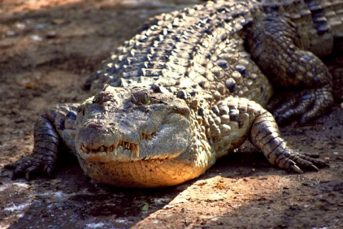
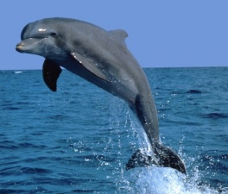
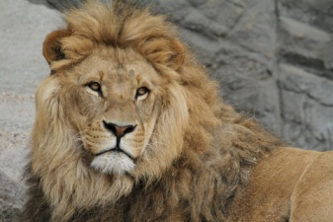
A. Lion B. Giraffe
C. Elephant D. Monkey
E. Dolphin F. Crocodile
G. Zebra H. Snake

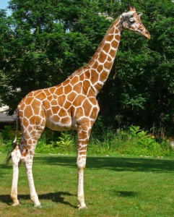
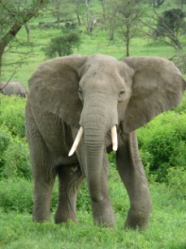
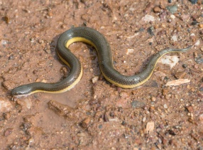
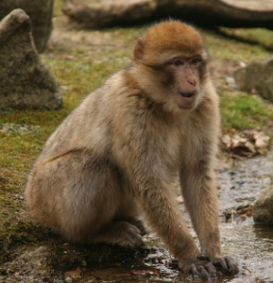

- Choose the correct options. (2*4=8 Points)
My parents ____________ in 1991.
A). had a child
B). were born
C). got married
D). graduated
…………………………………
English Language Teacher
Teacher: When was Atatürk born?
Student: __________________ .

A). in 1881
B). in Selanik
C). two awards
D). Şemsi Efendi School

