..……-…..… EDUCATIONAL YEAR
…………………………… SECONDARY SCHOOL
7TH GRADE1STTERM 1ST EXAM
Duration: 40 minutes
Name-Surname:……………………………………… Class:…………… Number:………
- Categorize the words. (10*2= 20 Points)
A. handsome B. punctual C. stubborn D. Slim E. Thoughtful
F. overweight G. tall H. honest I. Friendly J. Brown eyes

Personality
Appearance

- Complete the sentences with adjectives in the box. (7*2= 14 Points)
honest

punctual

lazy

generous

selfish

polite

stubborn

-She wants everything for herself. She is ___________ .
-My brother doesn’t tell lies. He is ___________ .
-Ünal has got a lot of money and he helps poor people. He is ___________ .
-My sister always says “thank you”. She is a ___________ person.
-My father never changes his mind. He is ___________ .
-Sevda teacher is never late. She is very ___________.
-My daughter never does his homework. She is ___________ .
- Write the comparatives of the adjectives. (5*2= 10 Points)
- Antalya is __________________ (hot) than Ağrı.
- A computer is __________________ (expensive) than radio.
- Milk is __________________ (good) than coffee.
- My cousin is __________________ (slim) than my sister.
- Ünal teacher is __________________ (funny) than me.

- Answer the questions using the the words in brackets. (4*3= 12 Points)
-How often do you play tennis? (twice a day)
________________________________________________________
-How often does she go to dance club? (every sunday)
________________________________________________________
-How often do they play golf? (never)
________________________________________________________
-How often does it sleep? (always)
________________________________________________________

- Look at the table and fill in the blanks. (10*2= 20 Points)

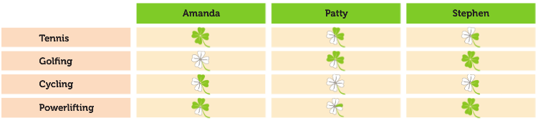

a. Amanda always plays tennis . (play tennis) g. Patty _____________________ . (go cycling)
b. Amanda _____________________ . (play golf) h. Patty _____________________ . (do powerlifting)
c. Amanda _____________________ . (go cycling) i. Stephen _____________________ . (play tennis)
d. Amanda _____________________ . (do powerlifting) j. Stephen _____________________ . (play golf)
e. Patty _____________________ . (play tennis) k. Stephen _____________________ . (go cycling)
f. Patty _____________________ . (play golf)
6. Match the sports with the pictures. (8*3= 24 Points)
a. skiing b. surfing c. volleyball d. Cycling
e. roller skating f. climbing g. Scuba diving h. horse-riding

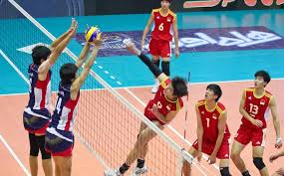
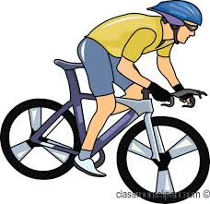
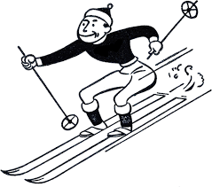
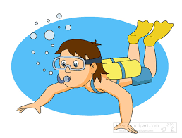
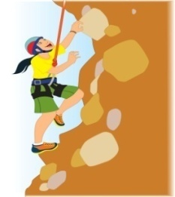

GOOD LUCK!😊
……………………………
English Language Teacher

