………….. – ………….. EDUCATIONAL YEAR
…………………………………….. SECONDARY SCHOOL
7TH GRADE 1ST TERM 1ST EXAM
Duration: 40 minutes
Name-Surname:……………………………………… Class:…………… Number:………
- Categorize the words. (10*2= 20 Points)
A. handsome B. punctual C. stubborn D. slim E. selfish
F. plump G. tall H. honest I. outgoing J. blue eyes

Appearance
Personality

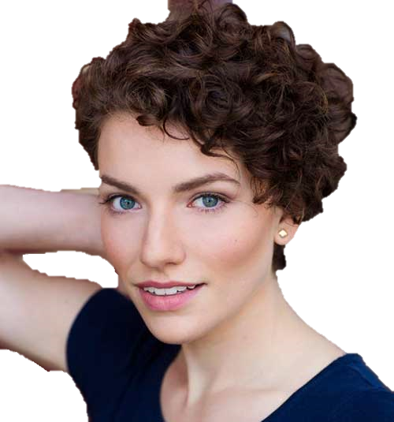
- Read the paragraph and circle the correct word. (8*2= 16 Points)

Hello, I’m Kate. I have short/long and straight/wavy hair. My friends say I’m beautiful with dark/blonde hair. My eyes are black/blue. This is my best friend, Rosie. She has got short/long and blonde/brown hair. She is so pretty with curly/straight hair. Her eyes are brown/blue.

Rosie
Kate

- Order the frequency adverbs and write the meanings of them. (10*2= 20 points)
 | Frequency Adverbs | Anlam
*****
****
***
**
*

Sometimes
Always
Rarely
Usually
Often

- Answer the questions using the the words in brackets. (3*4= 12 Points)
-How often do you play basketball? (twice a week)
________________________________________________________
-How often does she go to the gym? (every Sunday)
________________________________________________________
-How often does he play football? (always)
________________________________________________________
- Write the comparatives of the adjectives. (6*2= 12 Points)
- Antalya is __________________ (hot) than Ağrı.
- A computer is __________________ (expensive) than radio.
- Milk is __________________ (good) than coffee.
- My cousin is __________________ (slim) than my sister.
- Zeynep teacher is __________________ (funny) than me.
- My sister is __________________ (punctual) than my brother.

- Look at the table and fill in the blanks. (4*3= 12 Points)

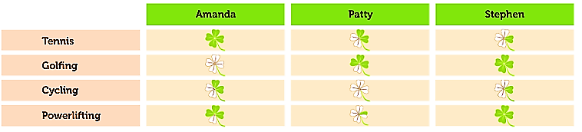

a. Amanda always plays tennis . (play tennis) d. Patty _______________________ . (go cycling)
b. Amanda _______________________ . (go cycling) e. Stephen _____________________ . (play tennis)

- Choose the correct options. (2*4= 8 Points)
City | Yesterday | Today
Antalya | 29 | 34
Ağrı | 11 | 15
İstanbul | 24 | 20

Which one is TRUE?
A). Antalya is colder than İstanbul today.
B). Ağrı was hotter than İstanbul yesterday.
C). İstanbul is colder than Ağrı today.
D). Antalya was hotter than Ağrı yesterday.
Emma: _________________________?
Jack: Once a week.
What is the best question according to the answer?
A). Do you like indoor sports?
B). Why do you play football?
C). How often do you train?
D). Where do you play volleyball?

………………………………….
English Language Teacher

