………. – ………. EDUCATIONAL YEAR
…………………………………. SECONDARY SCHOOL
7TH GRADE 1ST TERM 1ST EXAM
Duration: 40 minutes
Name-Surname:……………………………………… Class:…………… Number:………
- Categorize the words. (10*2= 20 Points)
A. handsome B. punctual C. stubborn D. slim E. selfish
F. curly hair G. tall H. honest I. outgoing J. blue eyes

Personality
Appearance

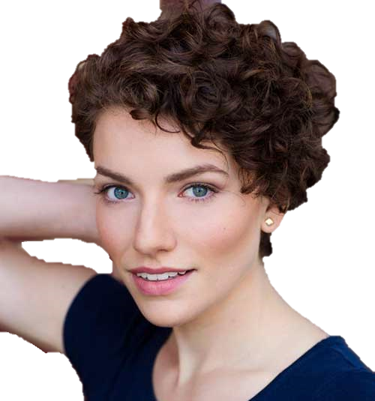
- Read the paragraph and circle the correct word. (8*2= 16 Points)

Hello, I’m Anna. I have short/long and straight/wavy hair. My friends say I’m beautiful with dark/blonde hair. My eyes are black/blue. This is my best friend, Betty. She has got short/long and blonde/brown hair. She is so pretty with curly/straight hair. Her eyes are brown/blue.

Anna
Betty

- Order the frequency adverbs and write
- Write the comparatives of the adjectives. (6*2= 12 Points)
- Ağrı is _____________ (cold) than Antalya.
- Milk is _____________ (good) than coffee.
- My sister is _____________ (slim) than my brother.
- Ezgi teacher is _____________ (funny) than me.
- My father is _____________ (punctual) than my mother.
- A computer is _______________ (expensive) than radio.

the meanings of them. (10*1= 10 points)
Sometimes – Always – Rarely – Usually – Never

 | Frequency Adverbs | Meaning
%100
%90
%50
%10
%0

- Answer the questions using the the words in brackets. (2*4= 8 Points)
-How often do you play basketball? (twice a week) ____________________________________________________
-How often does she go to the gym? (never)
____________________________________________________
- Match the words with the pictures. (7*2= 14 Points)
a. skiing b. surfing c. swimming d. cycling e. ice skating f. jogging g. doing judo
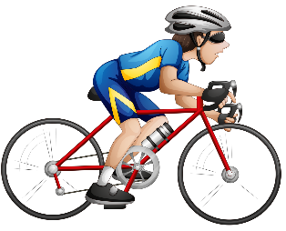
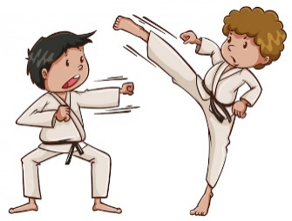

- Look at the table and fill in the blanks. (4*3= 12 Points)

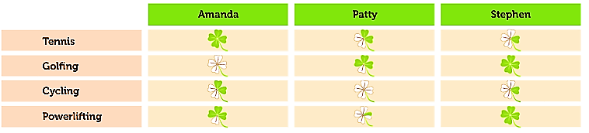

a. Amanda always plays tennis . (play tennis) d. Patty _______________________ . (play golf)
b. Amanda _______________________ . (play golf) e. Stephen _____________________ . (go cycling)

- Choose the correct options. (8 Points)
Steve: _________________________?
Terry: Once a week.
What is the best question according to the answer?
A). Do you like indoor sports?
B). Why do you play football?
C). How often do you train?
D). Where do you play volleyball?
………………………………..
English Language Teacher

