………..-………… EDUCATIONAL YEAR
…………………………. SECONDARY SCHOOL
7TH GRADE1STTERM 2ND EXAM
Duration: 40 minutes
Name-Surname:……………………………………… Class:…………… Number:………

- Write the words in the correct column. (8*2=16 points)
*clumsy *forgetful *friendly *lazy *punctual *selfish *generous *energetic

POSITIVE FEATURES 😊 | NEGATIVE FEATURES ☹

2. Write the past forms of the verbs below. (7*2=14 points)
PRESENT (V1) | PAST (V2)  3. Answer the questions. (3*4=12 points)  *A. …………………… animals such as dogs and cats are friendly to people.  a) Wild b) Strong c) Domestic d) Reptile  *B. It looks like a horse and donkey wearing pyjimas. It’s …………….  a) turtle b) zebra c) lion d) elephant  *C. I’m a bird. I have got colorful feathers. I can speak. I’m ………………  a) parrot b) giraffe c) dolphin d) snake
begin
drive
win
start
go
put
drink

4. Match the pictures with the sports names. (8*2=16 points)
A. Running B. Cycling C. Horse riding D. Rock climbing E. Swimming F. Roller skating G. Scuba diving H. Handball

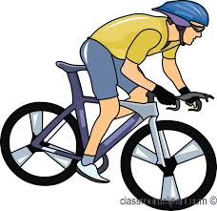
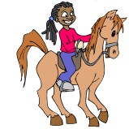
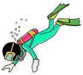

5. Match the pictures with the animals. (11*2=22 points)
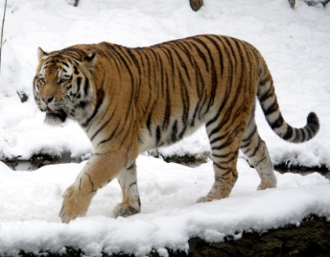
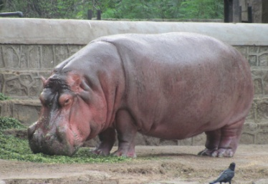
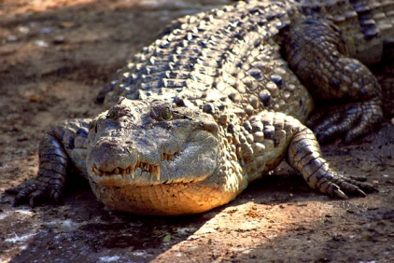
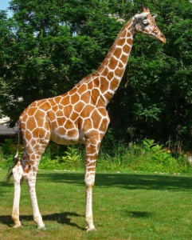
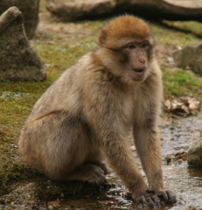
A. Lion B. Giraffe C. Elephant D. Hippo E. Monkey F. Lizard G. Dolphin H. Crocodile I. tiger J. Zebra K. Snake
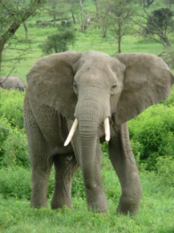
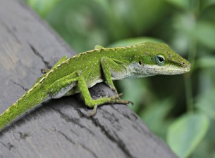
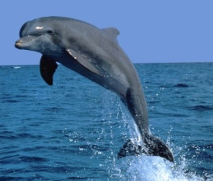
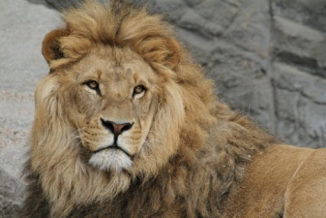
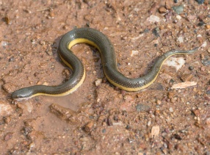
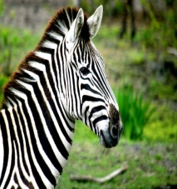

6. Fill in the blanks with the names of animals. (5*4=20 points)
A. Lion B. Leopard C. Hippopotamus D. Giraffe E. Ostrich

- _______________ is a wild cat with yellow and black spots.
- _______________ has got a long neck and it is very tall.
- _______________ is a big bird. It has got wings but it can’t fly.
- _______________ is the king of the jungle with strong claws.
- _______________ is a huge animal with a big mouth. It likes resting in water.

……………………………………
English Language Teacher

