**……..-……... EDUCATIONAL YEAR**

**………………………………… SECONDARY SCHOOL**

**7TH GRADE****1STTERM 2ND EXAM**

Duration: 40 minutes

Name-Surname:……………………………………… Class:…………… Number:………

1. **Write the meanings and past forms of the verbs below. (8*2=16 points)**

|  |  |  |  |  |  |
| --- | --- | --- | --- | --- | --- |
| **PRESENT (V1)** | **PAST (V2)** | **ANLAM** | **PRESENT (V1)** | **PAST (V2)** | **ANLAM** |
| **1.** Understand |  |  | **5.** Hear |  |  |
| **2.** Do |  |  | **6.** Leave |  |  |
| **3.** Give |  |  | **7.** Know |  |  |
| **4.** Teach |  |  | **8.** See |  |  |

1. 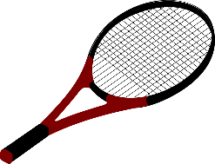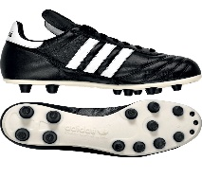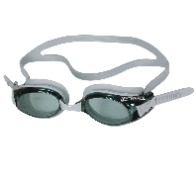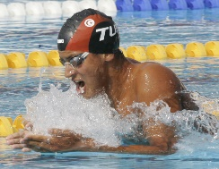**Match the sentences with the pictures. (5*2=10 points)**

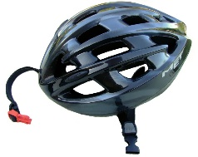

1. Footballers wear them on their feet while playing football.
2. You should wear it while skating. You can hit your head and get injured.
3. You hit the ball with it while playing tennis.
4. You should wear it to your head before you begin to swim.
5. You should wear it to your eyes while swimming.

**4. Complete the sentences with “in/on/at”. (7*1=7 points)**

**\*** He was born …… 1991.

**\*** She goes to the park …… Sundays.

**\*** We had dinner ………. 07.00 pm.

**\*** He died ……. 21st May, 2003.

**\*** They go to Zeytinada …… summer.

**\*** I listened to music ……. night.

**\*** I fed my cat ……. the evening.

**5.** **Answer the questions. (3*2=6 points)**

**3. Fill in the blanks with the past forms the verbs. (10*2=20 points)**

Barış MANÇO was extraordinary public figure. He …………..**(be)** a musician and a programme producer. He was born on January 2,1943 in İstanbul. He …………………**(graduate)** from Şişli Terakki High School. Then, he ………....**(move)** to Belgium to study at Royal Academy of Arts. He ……………**(come)** back to Turkey in 1970. He …………….**(get)** married to Lale MANÇO in 1978. They……………… **(raise)** to children. He …………….. **(produce)** a programme called ‘from 7 to 77 with Barış MANÇO’. It was a family and children oriented programme. He ……………. **(found)** a group called ‘Kurtalan Ekspres’. He ……………..**(win)** some awards such as ‘International Culture and Peace Award’ from Japan in 1991 and ‘Highest Honour of Art’from Japan again in 1995. He ………….**(die)** on January 31,1999.

* It has got long neck and long legs. It’s yellow with brown spots. It is ………………………….. .

a) Cheetah b) Tiger c) Giraffe d) Leopard

* It looks like a horse and donkey wearing pyjimas. It’s ………………………. .

a) Tortoise b) Zebra c) Lion d) Elephant

* It has got sharp claws. It can see its prey clearly when flying very high. It’s ……………… .

a) Parrot b) Penguin c) Butterfly d) Eagle

**6.** **Match the pictures with the animals. (8*2=16 points)**

**A.** Giraffe **B.** Elephant **C.** Hippo **D.** Lizard **E.** Dolphin **F.** Crocodile **G.** tiger **H.** Snake

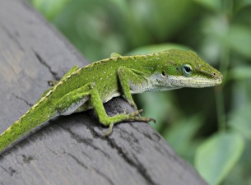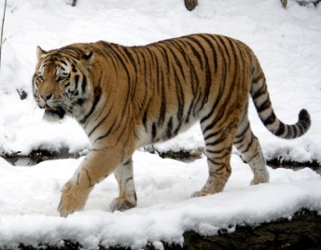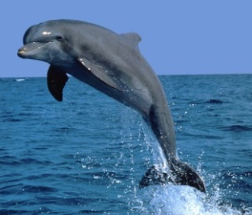

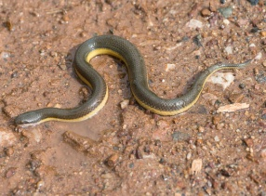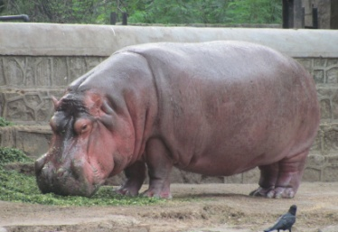

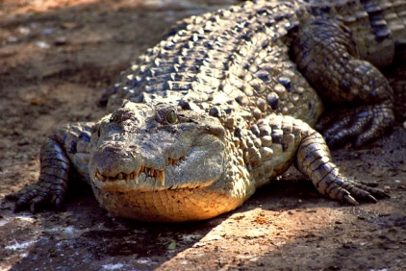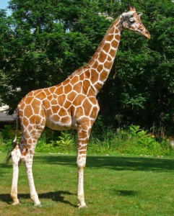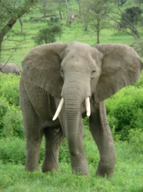

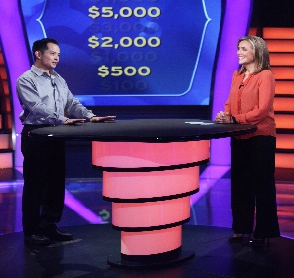**7. Match the pictures with TV Programmes. (5*2=10 points)**

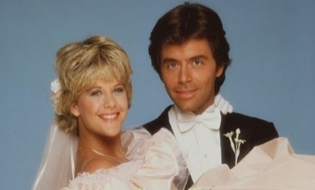

**9. Write the years in words. (3*2=6 points)**

**1992:** **___________________________**

**2018: ___________________________**

**2000: ___________________________**

**8. Write a sentence by using “prefer”. (9 points)**

**\***news (+) / reality shows (-)

**___________________________________ .**

**\***watch movies (+) / watch tv series (-)

**___________________________________ .**

**A.** Cartoons **B.** Cookery Programmes **C.** Quiz Shows **D.** Soap Operas **E.** News



**…………………………………….**

**English Language Teacher**