…………….. – ……………. EDUCATIONAL YEAR
…………………………………………. SECONDARY SCHOOL
7TH GRADE 1ST TERM 2ND EXAM
Duration: 40 minutes
Name-Surname:……………………………………… Class:…………… Number:………

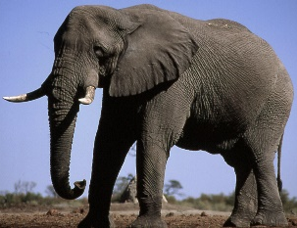
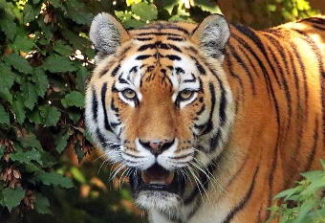
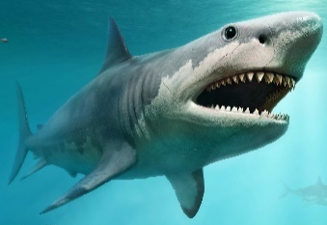
- Match the pictures with the animals. (10*2 = 20 Points)

A. Tiger
B. Lizard
C. Chimpanzee
D. Eagle
E. Crocodile
F. Shark
G. Owl
H. Horse
I. Elephant
J. Camel

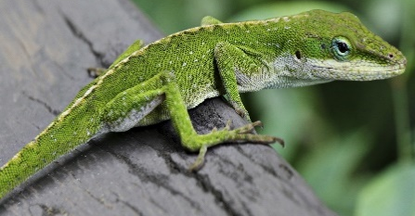
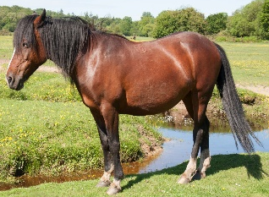
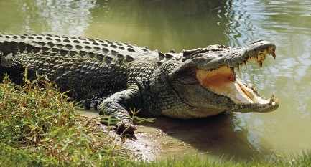

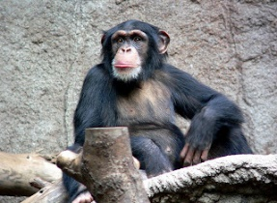
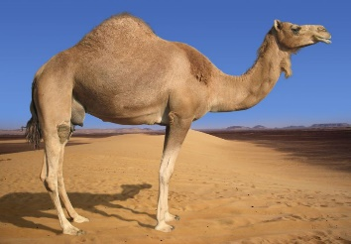
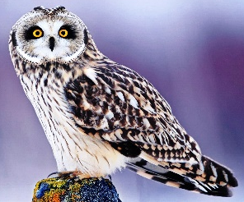

MEANING | PRESENT (V1) |  | PAST (V2) |  | MEANING | PRESENT (V1) |  | PAST (V2)
 | 1. go |  | had |  |  | 4. leave |  | ate
 | 2. have |  | drank |  |  | 5. do |  | left
 | 3. drink |  | went |  |  | 6. eat |  | did
- Match the present form with the past form of verbs and write their meanings. (12*1 = 12 points)

- Rewrite the sentences using “should” or “shouldn’t”. (4*4 = 16 Points)
- Protect wild animals. We _______________________________________________ .
- Pollute the environment. We ________________________________________________.
- Destroy the wild animals’ habitats. We ________________________________________________.
- Stop hunting animals. We _____________________________________________________.

- Categorize the animals according to their species. (9*2 = 18 Points)
A. Snake F. Lion
B. Elephant G. Lizard
C. Dolphin H. Owl
D. Eagle I. Crocodile
E. Stork

MAMMALS | REPTILES | BIRDS

- Fill in the blanks with the past forms the verbs. (9*2=18 points)
Barış MANÇO ………….…… (be) born on January in İstanbul in 1943. He ……………………… (graduate) from Şişli Terakki High School. Then, he ……………...... (move) to Belgium to study at Royal Academy of Arts. He …………………… (come) back to Turkey in 1970. He ……………..……. (get) married to Lale MANÇO in 1978. They ………………… (raise) to children. He ……………….. (produce) a programme called ‘from 7 to 77 with Barış MANÇO’. It was a family and children oriented programme. He founded a group called ‘Kurtalan Ekspres’. He ………………….. (win) some awards such as ‘International Culture and Peace Award’ from Japan in 1991 and ‘Highest Honour of Art’from Japan again in 1995. He ……………….…. (die) in 1999.

- Complete the dialogue. (4 Points)
Alice: How often do you go jogging?
Tom: ………………………………………….
A. It is an outdoor activity.
B. I like documentaries.
C. Yes, I do.
D. Twice a week.

- Circle the correct options. (4*1 = 4 Points)

- Camels live in marsh / desert.
- Snakes are poisonous / extinct animals.
- Lions are carnivores / herbivores.
- Kangaroos can jump / fly.

- Choose the best option according to the picture.
(4 Points)

- Choose the best option. (4 Points)
Lions are …………………….. animals.
A. poisonous B. herbivore
C. wild D. extinct

A. She got married.
B. She won the Nobel prize.
C. She moved to London.
D. She graduated from university.

…………………………………….
English Language Teacher

