……..…. - …………. EDUCATIONAL YEAR
………………………………. SECONDARY SCHOOL
7TH GRADE 2ND TERM 1ST EXAM
Duration: 40 minutes
Name-Surname:……………………………………… Class:…………… Number:………
- Match the signs with the sentences. (7*2=14 points)
- Suitable for all ages.
- Suitable for children over 13 years old.
- This programme includes violence.
- Suitable for children over 7 years old.
- It may cause bad behaviour.
- Suitable for children over 18 years old.

- Look at the chart and write sentences using “I prefer ……to……”. (4*4= 16 points)
Soap Opera | TV Series
Quiz Show | Talk Show
News | Sitcom
Talk Show | Reality Show

- Match the pictures with the party names. (5*2=10 points)
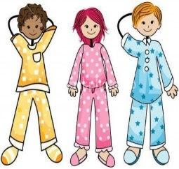
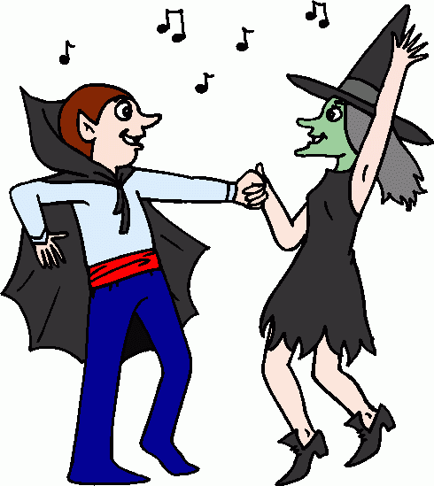
A. Fancy Dress Party B. Pyjamas Party C. Birthday Party D. Graduation Party E. Wedding Party

- Write the words in the correct column. (6*3=18 points)
- Circle the correct alternative.
(4*3=12 points)

- There is a little / a few milk in the bottle
- We saw many / much people in the party.
- She prefers any / some coffee.
- Mary has much / a lot of presents.

A. Friday the thirteenth B. Blue beads C. Opening an umbrella indoors
D. Walking under a ladder E.Horseshoe F. Four-leaf clover

GOOD LUCK | BAD LUCK
_  _  _ | _  _  _

5. Fill in the blanks with “Simple Past Tense” or “Future Tense”. (5*3=15 points)
A. I _____________ (go) to shopping with my mother yesterday. (+)
B. You _____________ (marry) next week. (+)
C. I _____________ (go) to football match tomorrow. (-)
D. She _____________ (visit) her grandparents three days ago. (-)
E. He _____________ (have) breakfast with his friends next Saturday. (+)

6. Prepare an invitation card. (15 points)

Party Type:
Date:
Place:
Time:
Guests:

……………………………………..
English Language Teacher

