………… – ………… EDUCATIONAL YEAR
………………………………………. SECONDARY SCHOOL
7TH GRADE 2ND TERM 2ND EXAM
Duration: 40 minutes
Name-Surname:……………………………………… Class:…………… Number:………
- Complete the sentences with “public buildings”. (8*2 = 16 Points)
A. greengrocer B. library C. cafe D. museum E. sports centre F. butcher G. clothes shop H. art gallery

*You can go to the ……….…….….. to see ancient statues. *If you want to buy meat, you should go to the…………..…..
*I will go to …………..…………..… to borrow a book. *You should go to a ………..……….… if you want to drink tea.
*If you want to buy a sweater, you go to the .................. *We will go to the …………….……… to see paintings.
*They will go to the …………………... to do gymnastics. *If you need tomatoes, you should go to the ………….………

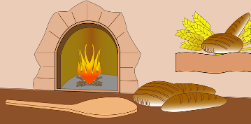
- Look at the pictures and write your sentences using “to”. (3*4 = 12 Points)
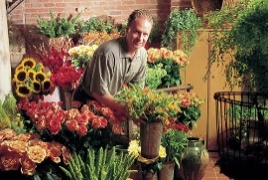
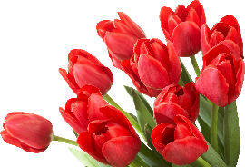
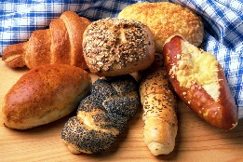

- Match the environmental problems with their solutions. (4*2 = 8 Points)
- Air pollution
- Deforestation
- Water pollution
- Wasting energy
- Plant a tree !
- Don’t leave the lights on !
- Use filters in factories !
- Don’t throw rubbish into the sea !

- Answer the questions. (2*3 = 6 Points)
For a clean environment : ………………………………
A. Don’t use public transportation!
B. Cut down trees!
C. Put the rubbish in the recycling bin!
D. Don’t stop using harmful chemicals!
What must people do to prevent global warming?
A. They mustn’t use solar energy.
B. They mustn’t use aerosol products.
C. They must throw rubbish.
D. They must pour chemicals into the sea.

- Fill in the blanks with “must” or “mustn’t”. (7*2 = 14 Points)
- Factories ____________ use filters to prevent air pollution.
- People ____________ destroy the forests.
- People ____________ use more solar energy and wind energy.
- We ____________ use eco-friendly products.
- We ____________ make a fire among trees.
- We ___________ waste our water.
- People ____________ keep the environment clean.

- Write the words in the correct order. (5*4 = 20 Points)
- the trees / we / cut down / mustn’t
_______________________________________________________ .
- mustn’t / cars / private / always / people / drive
_______________________________________________________ .
- use / people / sources / must / energy / renewable
_______________________________________________________ .
- energy / we / bulbs / must / at home / saving / use
_______________________________________________________ .
- mustn’t / greenhouse / people / use / gases
_______________________________________________________ .

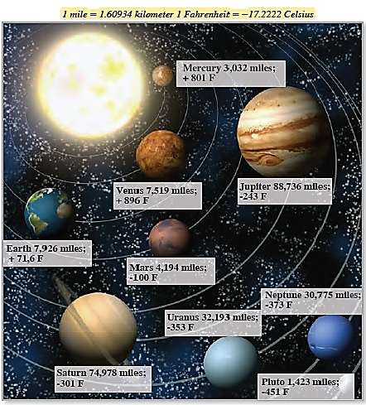
- Look at the diameter and temperature of each planet. Write “comparative sentences” using the words given below;
big / small
hot / cold
close to the Sun / far from the Sun
(6*4 = 24 Points)
- ……………………………………………………………………
- ……………………………………………………………………
- ……………………………………………………………………
- ……………………………………………………………………
- ……………………………………………………………………
- …………………………………………………………………...
………………………………..
English Language Teacher

