…….…… - …….…… EDUCATIONAL YEAR
………………………………………………… SECONDARY SCHOOL
7TH GRADE 2ND TERM 2ND EXAM
Duration: 40 minutes
Name-Surname:……………………………………… Class:…………… Number:………
- Write “GOOD LUCK” or “BAD LUCK”. (10*2= 20 Points)
Friday the thirteenth __________________________ Seeing a black cat____________________________
Opening an umbrella indoors____________________ Walking under a ladder_________________________
Cutting nails at night___________________________ Horseshoe_________________________
Spilling salt________________________ Four leaf clover_____________________
Bluebeads_________________________ Whistling at nights___________________

- Circle the correct one. (5*2= 10 Points)
- There is a little / a few milk in the bottle
- I don’t have some / any money in my pocket.
- We saw many / much people in the party.
- She prefers any / some coffee.
- Mary has much / a lot of presents.

- Read the dialogue and write the needs below. (8*2=16 Points)
Father: Mary, I'm at the supermarket. What do we need for the birthday cake and birthday party?
Mother:Well, firstly, let me look at the fridge! We don't have any eggs. Buy 5 eggs and some milk and some sugar.
Father: OK. What else?
Mother: Oh, buy some candles and 25 party hats. Also, buy 30 balloons, confetti and a lot of lemonade.
Father: OK. I'll be home in an hour.

Shopping List !!!
- -
- -
- -
- -

- Match the pictures with their names. (6*2=12 Points)
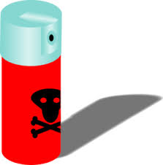
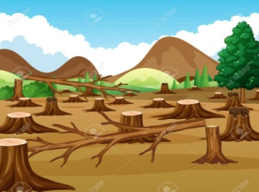
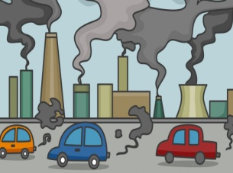
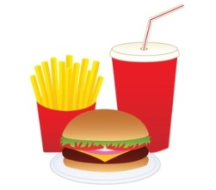
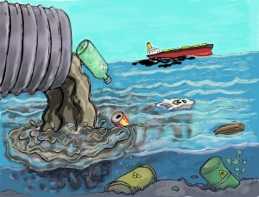

a.) Junk food b.) recycle c.) deforestation d.) water pollution e.) pesticide f.) air pollution

- Read the sentences and write the types of TV programmes. (6*3= 18 Points)
A—Sitcom B—Talk Show C—Quiz Show D—News E—Discussion F – Reality Show

A group of people come together to discuss a topic.
People compete with each other by trying to answer questions.
It is an amusing TV series about fictional characters.
It gives information about current events.
It shows real events about ordinary people.
Some guests talk about their lives and works.

- Complete the sentences with “public buildings”. (18*3= 24 Points)
department store – movie theatre – fire station – coffee shop – bookshop – amusement park – chemist’s – bakery

*If there is a fire, you should call the ……….…….….. *If you want to buy some bread, you should go to the…………..
*I will go to …………..…………..… to buy a book. *You should go to a ………..……….… if you want to drink coffee.
*If you want to buy a t-shirt, you go to the ................... *We will go to the …………….……… to have some fun with kids.
*They will go to the …………………... to watch a new film. *If you need some medicine, you should go to the ………….……

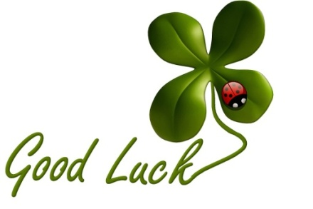
……………………………………..
English Language Teacher

