…………… - ………….. EDUCATIONAL YEAR
……………………………………. SECONDARY SCHOOL
7TH GRADE 2ND TERM 2ND EXAM
Duration: 40 minutes
Name-Surname:……………………………………… Class:…………… Number:………
- Complete the sentences with “will” or “won’t”. (5*2 = 10 Points)
- Emily _____________ move to London next week.
- Thomas _____________ go to the rock concert next weekend.
- Fred _____________ wash his car tomorrow.
- Eric _____________ visit his grandparents next Sunday.
- Carol _____________ graduate from the university this year.

A. city hall
B. supermarket
C. police station
D. bakery
E. coffee shop
F. department store
G. hospital
H. cinema
I. chemist’s
J. music store
- Complete the sentences with “public buildings”. (10*3 = 30 Points)
- You go to the _______________ to report the burglary.
- You can go to the _______________ to see a doctor.
- You should go to the _______________ to buy a fresh cupcake.
- You go to the _______________ to buy some pills and vitamins.
- You can go to the _______________ to buy some eggs, milk and tomatoes.
- You go to the _______________ to watch a movie.
- You go to the _______________ to drink coffee and tea with your friends.
- You go to the _______________ to buy your favourite music CDs.
- You can go to the _______________ to pay the bills.
- You should go to the _______________ to buy a new suit for your sister’s wedding ceremony.

- Complete the sentences with “should” or “shouldn’t”. (10*2 = 20 Points)
- We _____________ cut down the trees.
- We _____________ use more solar and wind energy.
- We _____________ stop polluting the air and seas.
- We _____________ litter the streets.
- We _____________ buy eco-friendly products.
- We _____________ plant more trees.
- We _____________ use public transportation.
- We _____________ destroy the rainforests.
- We _____________ hunt the animals.
- We _____________ recycle waste materials.

- Match the pictures with the “public buildings”. (5*2 = 10 Points)
A. Post Office B. School C. Amusement Park D. Zoo E. Mosque
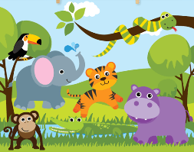

- What can you find in these buildings? (4*2 = 8 Points)
- Cafe
A. CDs B. Coffee C. medicine

- Chemist’s
A. medicine B. flowers C. muffins

- Bakery
A. books B. cupcakes C. vegetables

- Florist’s
A. flowers B. pills C. cookies

- Match the sentences with the pictures.(5*2=10 Points)
A. We must stop destroying the forests.
B. We mustn’t waste water.
C. We must use renewable energies.
D. We must recycle glass, plastic, paper etc.
E. We mustn’t pollute the seas.

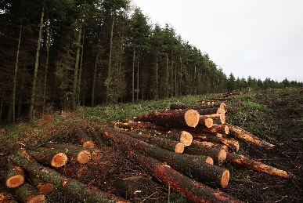
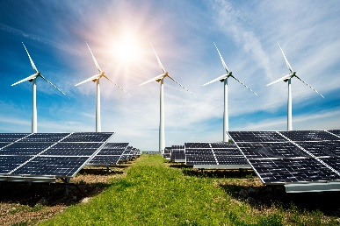

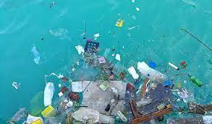

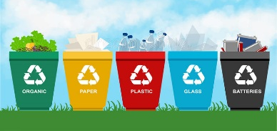

Answer the multiple questions given below.
(3*4 = 12 Points)
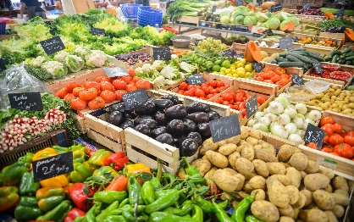
- Let’s go to the ________. I need some tomatoes and potatoes.

A. school B. fire station
C. greengrocer D. post Office

- Tom: Where are you going?
Frank: I’m going to the city hall to ____________.

A. buy some pills and vitamins
B. pay the bills
C. watch a movie/film
D. drink a cup of coffee

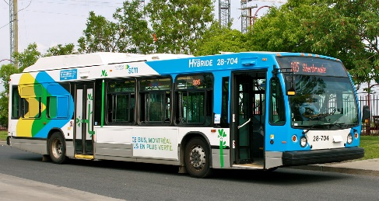
- We must ____________ because carbon dioxide in the air is increasing day by day.

A. use public transportation
B. use solar and wind energies
C. use eco-friendly products
D. plant trees
GOOD LUCK ! 😊
…………………………………
English Language Teacher

