…..….. – ….…… EDUCATIONAL YEAR
……………………………………….. SECONDARY SCHOOL
8TH GRADE 1ST TERM 1ST EXAM
Duration: 40 minutes
Name-Surname:……………………………………… Class:…………… Number:………
- Read the sentences and put (I) for Inviting, (A) for Accepting, (R) for Refusing. (8*2=16 Points)
(….) a. I don’t think it’s a good idea. (….) e. Sure, it sounds awesome.
(….) b. Cool! I’ll be there. (….) f. Shall we go to see a movie?
(….) c. Would you like to join us? (….) g. That sounds bad.
(….) d. I am sorry but I can’t. (….) h. Yeah, I’d love to. What time is it?
- Fill in the blanks with “Shall we / What about / Would you like”. (7*2=14 Points)
- ………………………….. to read cartoon magazine?
- ………………………….. organising a surprise concert for disabled children?
- ………………………….. drink coffee at Deren’s Cafe?
- ………………………….. inviting your friends to slumber party?
- …………………………. to make a birthday cake?
- …………………………. listening to Jazz music?
- …………………………. buy a big present for Samuel?
- Read the dialogue and complete the blanks with the correct sentence. (5*2=10 Points)
Waiter: ____________________________ (1)
*No, that’s all. Thanks.
*What would you like to eat?
*Hello, May I take your order?
*OK, What would you like to drink?
*can I take the menu, please?
Fred: Yes but first, ___________________________ (2)
Waiter: Of course, here you are. _____________________ (3)
Fred: I don’t want to eat anything but I would like to drink something.
Waiter: ___________________________ (4)
Fred: I’d like a cup of ice coffee.
Waiter: All right. Would you like to have a dessert?
Fred: _________________________ (5)
- Match the words with their definitions. (5*2=10 Points)
a. | Unbearable |  | ……… | Ordinary; usual.
b. | Typical |  | ……… | To have a good relationship
c. | Greet |  | ……… | To say hello to someone
d. | Get on well with |  | ……… | To support someone
e. | Back up |  | ……… | Something that you can’t stand

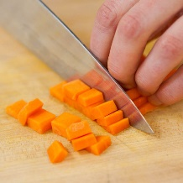
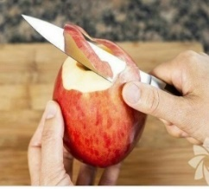
- Match the cooking methods with the pictures. (8*2=16 Points)
A. Peel
B. Fry
C. Mash
D. Slice
E. Pour
F. Dice
G. Boil
H. Bake

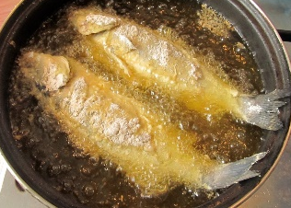
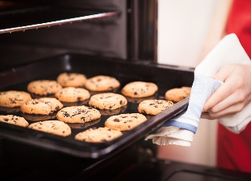
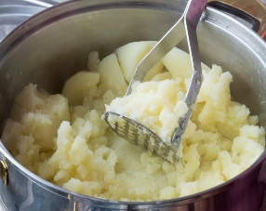
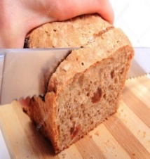

- Order the sentences for the recipe. (6*3=18 Points)
PANCAKE RECIPE
(.......) Then, heat it.
(.......) Next, pour 1 tablespoon of mixture into a frying pan.
(.......) After that, turn it upside down and heat again.
(.......) First, put the salt, sugar, flour and baking powder in a bowl and mix them.
(.......) Finally, serve your pancake with strawberry jam. Enjoy it!
(.......) Second, add milk and egg and stir them.

- MULTIPLE CHOICE QUESTIONS – Choose the correct options. (4*4=16 Points)
Dora: How often do you eat junk food?
Tim: __________. I prefer vegetables and fruit.
A). I always eat junk food.
B). I think junk food is delicious.
C). I fond of junk food.
D). I never eat junk food.
Jessy is an eleven-years-old boy. He gets up at seven o’clock in the morning and he walks to school. He has lunch at school canteen. He comes back home at half past three and he rests for a while. After that, he does homework and he plays with his friends.
Which question can’t we answer?
A). How old is he?
B). What does he have for lunch?
C). What does he do after school?
D). How does he go to school?

Sam: __________________________?
Jim: I usually see a movie with my family on Sundays.
A). What kind of movies do you prefer?
B). How do you go to cinema?
C). What do you need for watch a movie?
D). How often do you go to the movie?

Bob: ___________________________?
Mary: I usually read cartoon magazines after dinner and I sometimes play video games.
A). What time do you go to bed?
B). How often do you play video games?
C). What do you do in the evenings?
D). What kind of magazines do you prefer reading?

GOOD LUCK!😊
………………………………
English Language Teacher

