…………. – …………. EDUCATIONAL YEAR
………………………………… SECONDARY SCHOOL
8TH GRADE 1ST TERM 2ND EXAM
Duration: 40 minutes
Name-Surname:……………………………………… Class:…………… Number:………

- Match the words with the pictures. 10*2 = 20 Points)
A. Social Media F. File attachment
B. Download G. Confirm
C. Upload H. Web browser
D. E-mail I. Wireless
E. Password J. Screen

- Reorder the dialogue and number it. (10*2 = 20 Points)
_____ Pamela: Yes, please. Could you tell her to call me back?
_____ Tim: All right, thank you. I will tell her when she gets back home. Bye!
_____ Pamela: Ok, no problem. I can repeat it. It’s 7563089.
_____ Tim: Hello, Mark speaking.
_____ Tim: I’m afraid she is not available now. She has gone out. Would you like to leave a message?
_____ Pamela: Thank you very much. Bye!
_____ Tim: Ok, Could I get your phone number, please?
_____ Pamela: Hi, Mark. This is Nancy, Alice’s friend. May I speak to your sister?
_____ Tim: I’m sorry. Could you repeat the phone number again, please. I think it is bad line.
_____ Pamela: Of course. It’s 7563089.

- Complete the phone conversation with the phrases in the box. (4*2 = 8 Points)
A. Can you please tell him that Fred called.
B. How can I help you?
C. He is not available now.
D. Can you put me through to Mr. Smith?
Secretary: Good morning. ABC Company. _______________?
Mr. Demon: Hello, this is Fred Demon. ______________________?
Secretary: I’m sorry, ________________. May I take your message?
Mr Demon: ______________________________.
Secretary: Of course sir, good bye.

- Match the halves of the phrases. (4*2 = 8 Points)
- Put - on a minute
- Hang - someone back
- Hold - up the phone
- Call - someone through

- Complete the boxes with the expressions. (6*2 = 12 Points)
- May I talk to Jack?
- This is Alex calling.
- Just a second, I will get him.
- It’s Frank speaking.
- Is Bob there, please?
- Hold the line, I’ll put you through to Mr. Brown.
Introducing Yourself
Connecting Someone

Asking To Speak Someone

- Translate the text from English to Turkish and answer the question below. (27 Points)
CHOCOLATE CAKE
The ingredients of chocolate cake are 3 eggs, 1 cup of oil, 1 cup of sugar, 1 cup of milk, 3 cups of flour, 2 tablespoons of cocoa and 2 teaspoons of baking powder. First, whisk the eggs and sugar in a large bowl. Second, put oil and milk into the mixture and stir it. Next, add some flour, baking powder and cocoa into the mixture and stir it again. Then, spread some oil into the cake pan and pour the mixture into it. After that, bake it at 170 degrees for 35 minutes. Finally, Slice the chocolate cake and serve warm. Enjoy it!
________________________
____________________________________________________________________________________________________________________________________________________________________________________________________________________________________________________________________________________________________________________________________________________________________________________________________________________________________________________________________________________________________________________________________________________________________________________________________________________________________________________________________________________________________________________________________________________________________________________________________________________________________________________________________________________________________________________________________________________________________________________________________________________________________________________________________________________________________________________________________________________________________________________

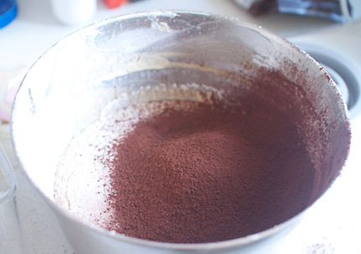
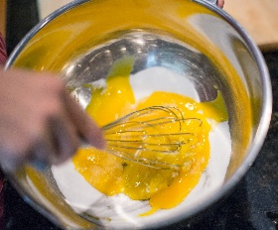
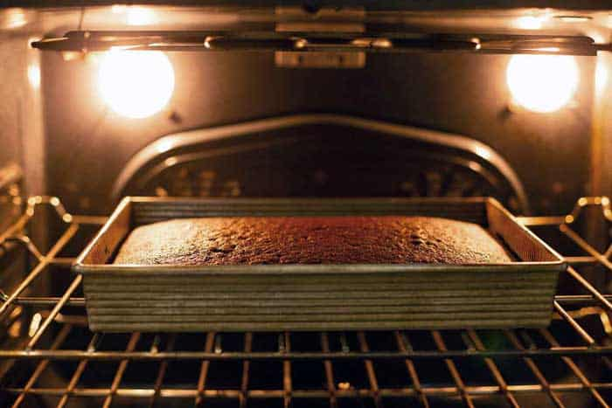
- According to the recipe above, what is the step before adding 1 cup of oil and 1 cup of milk into the mixture? (5 Points)
A. B. C. D.

………………………….
English Language Teacher

