**……..…. - …………. EDUCATIONAL YEAR**

**………………………………. SECONDARY SCHOOL**

**8TH GRADE 2ND TERM** **1ST EXAM**

Duration: 40 minutes

Name-Surname:……………………………………… Class:…………… Number:………

1. **Match the adventures with the pictures.**

**A.** Skydiving **B.** Scuba diving **C.** Rafting **D.** Hang-gliding

**E.** Surfing **F.** Trekking **G.** Bungee Jumping **H.** Skiing





**3. Fill in the blanks using comparatives.**

* Aslı is **________________ (slim)** than her sister.
* James is a **______________ (good)** footballer than the others.
* My friend’s house is **_____________ (wide)** than my house.
* My school is **________________ (noisy)** than my friend’s school.
* Maths exam is **_________________ (difficult)** than English exam.
* Bungee jumping is **_________________ (dangerous)** than surfing.

**2. Fill in the blanks using “prefer” or “would rather”.**

* We ___________ go camping than go swimming.
* I ____________ doing bungee jumping to going rafting.
* They ____________ going trekking to riding a horse.
* I _______________ fly in a hot-air balloon than ride an elephant.
* We ______________ go on jeep safari than ride a bicycle.
* I _______________ taking photos of the sharks to taking photos of the dolphins.

**4. Answer the multiple questions given below.**

**Which one are the expressions about?**

*All-inclusive resorts – Boutique Hotels – Bed and breakfast places*

1. Climate
2. Location
3. Cuisine
4. Accommodation

**Tim: ___________________________ ?**

**Ann: Yes. I went there last summer.**

1. Where did you go last summer?
2. Did you enjoy your holiday?
3. Have you ever been to Cappadocia?
4. When did you go to İzmir?

**5. Answer the questions according to the text given below.**

*Antalya is one of the most famous tourist destinations in Turkey. It is on the coast of the Mediterranean Sea. This growing city has lots of alternatives such as all-inclusive hotels, small hotels, ancient places, shopping malls, sports activities or natural places etc. Düden Waterfall, Köprülü Canyon, Konyaaltı Beach, Aspendos Ancient Theatre, Phaselis Ancient City, Alanya Castle, Antalya Aquarium, Antalya Zoo and lots of museums are some of the most important places to visit. You can do rafting, scuba diving, hiking, paragliding etc. Absolutely, you should see there.*

* What is the location of the city?

_________________________________________________________________________ .

* What are the alternatives can you see there?

_________________________________________________________________________ .

* What are the most important places can you visit?

_________________________________________________________________________ .

* What can you do there as water sports?

_________________________________________________________________________ .

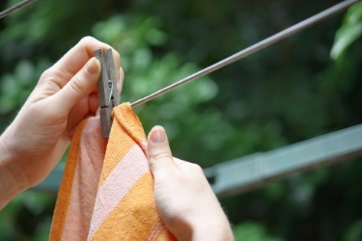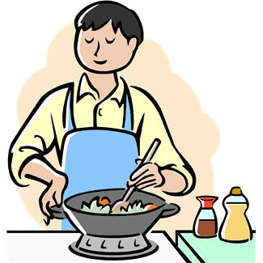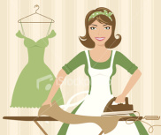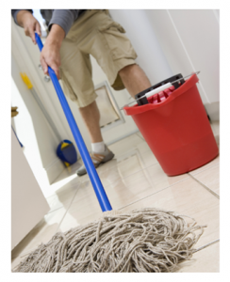**6. Match the answers with the questions.**

What is Tom doing?

What is Cathy doing?

What is Steve doing?

What is Susan doing?

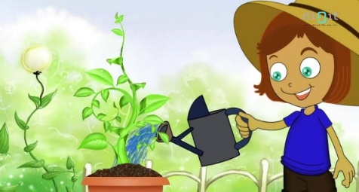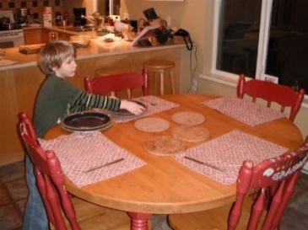

1. **He is setting the table.**
2. **She is ironing the clothes.**
3. **He is mopping the floor.**
4. **She is hanging out the washing.**
5. **He is cooking dinner.**
6. **She is watering the plants.**

What is Mary doing?

What is Mark doing?

**7.** **Complete the sentences with “mustn’t – “don’t have to” .**

* You ___________________ use your mobile phone on the plane.
* You ___________________ finish your homework because tomorrow is not deadline.
* You ___________________ polute the environment.
* You ___________________ smoke in this cafe.
* You ___________________ get up early because you don’t work.
* You ___________________ speak loudly in the library.
* You ___________________ wear school uniform beacuse it’s not necessary.
* You ___________________ cheat in the exams.

**______________________**

**English Language Teacher**

**GOOD LUCK ! 😊**