………….. - ………….. EDUCATIONAL YEAR
……………………………………. SECONDARY SCHOOL
8TH GRADE 2ND TERM 1ST EXAM
Duration: 40 minutes
Name-Surname:……………………………………… Class:…………… Number:………
- Fill in the blanks with given conjuctions. (5*3 = 15 Points)
and
but
because
- I can’t attend my online course _____________ I have a problem with my Internet connection.
- Steve has got an Instagram account _____________ he can’t log in.
- To log in your Facebook account, write your username _____________ enter your password.
- I would like to join your birthday party _____________ I have to study my English exam.
- I want to buy a new smartphone _____________ my mobile phone is broken now.

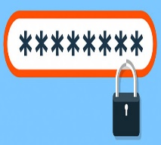
- Match the words with the pictures. (5*2 = 10 Points)
A. Password B. Upload C. Wireless
D. Download E. Web Browser

- Match the adventures with the pictures. (7*2 = 14 Points)
A. scuba diving B. kayaking C. caving D. paragliding E. skydiving F. heli-skiing G. hang-gliding
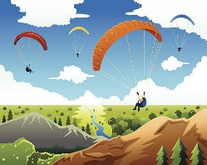
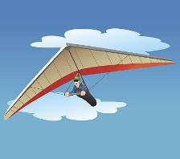
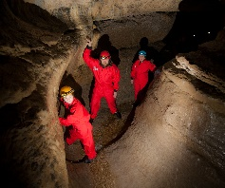
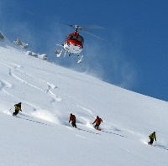
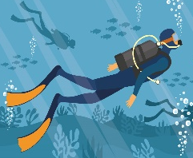
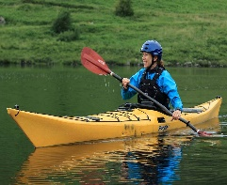
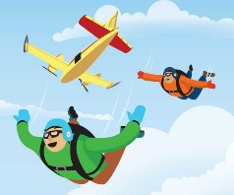

- Fill in the blanks using “prefer” or “would rather”. (4*3 = 12 Points)
- They ____________ going trekking to riding a horse.
- I ______________ fly in a hot-air balloon than go caving.
- We ___________ go camping than go swimming.
- I ____________ doing bungee jumping to going rafting.

- Fill in the blanks using comparatives. (4*3 = 12 Points)
- Hang-gliding is ______________ (dangerous) than canoeing.
- Rafting is _______________ (easy) than windsurfing.
- Climbing is ______________ (exciting) than caving.
- Scuba diving ______________ (good) than swimming.

- Put the words in order to make a meaningful sentence. (2*4 = 8 Points)
- think / more entertaining / I / is / bungee jumping / than rock climbing
_____________________________________________________________________________ .

- than scuba diving / is / think / less dangerous / I / canoeing
______________________________________________________________________________ .

- Answer the questions according to the text given below. (4*5 = 20 Points)
My favourite tourist destination is Antalya. It is on the coast of the Mediterranean Sea. The weather is not cold. Especially in summer it is usually too hot and sunny. You can find accommodation for every budget and you can see bed and breakfasts, all-inclusive hotels, five star hotels, guesthouses, bungalows to stay. There are lots of attractions such as ancient sites, castles, caves, museums, waterfalls, beaches, shopping malls, sport activities etc. You are never bored because the city offers various alternatives for everybody. Aspendos Ancient Theatre, Phalesis, Myra, Perge, Side and Olympos Ancient Sites, Alanya Castle, Damlataş Cave, Köprülü Canyon, Düden, Kurşunlu and Manavgat Waterfalls, Konyaaltı and Kaputaş Beaches, Kekova (Kaleköy) Island, Lycian Way, Yanartaş Mountain are some of the must-see places to visit. You can also try some exciting and entertaining activities such as rafting, scuba diving, paragliding, canoeing, caving, trekking etc. That sounds great. You should definitely go there.

A. What kind of water sports can you do in Antalya?
_________________________________________________________________________________________ .
B. How is the weather in Antalya?
_________________________________________________________________________________________ .
C. Where do you stay in Antalya?
_________________________________________________________________________________________ .
D. What are the must-see places in Antalya?
_________________________________________________________________________________________ .

- Answer the multiple questions given below. (3*3 = 9 Points)

James prefers a seaside holiday in summer.
What type of a holiday does James prefer in summer?

A. B.

C. D.

What can be the best title for this list?
___________________
All-inclusive Resorts – Boutique Hotels – Bed and breakfast
A. Climate B. Natural Ports
C. Accommodation D. Traditional Dishes

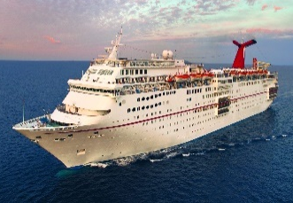
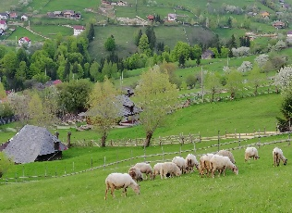

Put the sentences in the correct order to make a meaningful dialogue.
I. Yes, I spent a week with my family in Rome, Italy.
II. Really? How was it?
III. Have you ever gone abroad?
IV. It was incredible. I visited lots of historical sites.
A. II – I – III – IV B. III – I – II – IV
C. III – I – IV – II D. IV – III – I – II

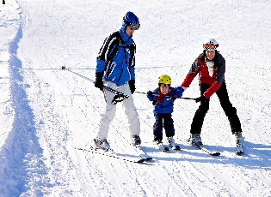
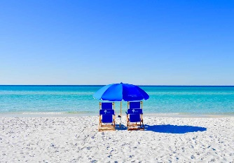

GOOD LUCK ! 😊
……………………………………
English Language Teacher

