…………. - …………… EDUCATIONAL YEAR
………………………………… SECONDARY SCHOOL
8TH GRADE 2ND TERM 2ND EXAM
Duration: 40 minutes
Name-Surname:……………………………………… Class:…………… Number:………
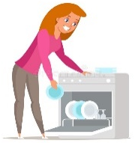
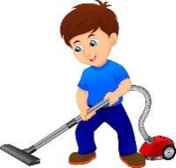


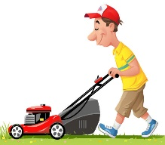
- Match the chores with the pictures. (10*3 = 30 Points)
A. do the laundry
B. mow the lawn
C. load/empty the dishwasher
D. vacuum the house
E. set the table
F. iron the clothes
G. wash the car
H. take out the garbage
I. clean the windows
J. cook the meals






- Write your 3 obligations/responsibilities at home or school. (3*4 = 12 Points)
- __________________________________________________________________________________
- __________________________________________________________________________________
- __________________________________________________________________________________

- Write the sentences by using “should” – “shouldn’t”. (5*3 = 15 Points)
- _______________________________________________________________.
- _______________________________________________________________.
- _______________________________________________________________.
- _______________________________________________________________.
- _______________________________________________________________.
- Vacuum the floor
- Tidy up the room
- Prepare dinner
- Do homework
- Fold the clothes

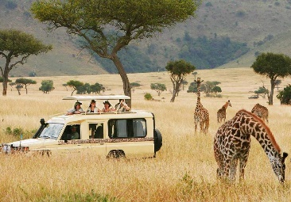

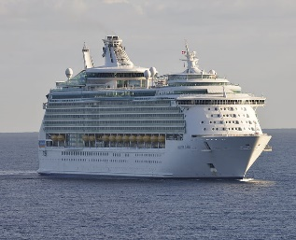
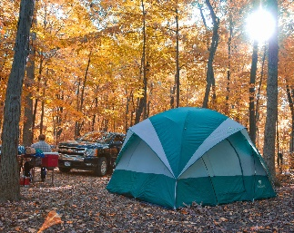

- Match the photos with the types of vacations. (5*3 = 15 Points)
A. safari B. cruise vacation C. seaside vacation D. camping E. winter vacation

Answer the multiple questions given below.
5 Points
1. What can be the best title for this list?
___________________
All-inclusive Resorts – Boutique Hotels – Hostels
A. Traditional Dishes B. Accommodation
C. Transportation D. Climate
5 Points

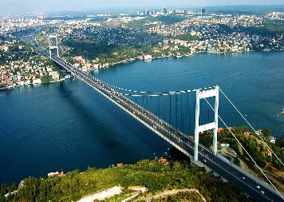
2. Choose the WRONG one.
A. B.

Bridge
Mosque

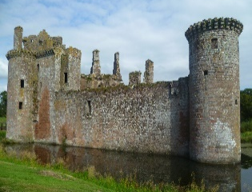

C. D.

Castle
Cave


3.
I usually prefer visiting historical sites but unfortunately, I don’t like modern buildings.
Andy


I really like travelling different places, but I’m sorry, I hate visiting historical places and museums. I think they are boring.

Mark

5 Points
Mark _______________________________.
A. dislikes modern buildings.
B. loves visiting museums.
C. thinks historical places are boring.
D. is interested in museums and historical places.

4.
5 Points
Tom: What are you doing now?
Frank: I’m reading a magazine.
Tom: _____________________?
Frank: It’s about inventors and inventions.

A. What do you think about inventions?
B. How often do you read a magazine?
C. Do you like following scientific achievements?
D. What is it about?

5.
4 Points
Tony: Do you know Marie Curie?
Susan: _______________. She is a famous chemist and physicist. She had studies on radiation and she got two Nobel prizes.

A. Yes, of course. B. No, I don’t know.
C. I think she isn’t a scientist. D. I’m sorry, I don’t.

6. Put the sentences in the correct order to make a meaningful dialogue.
4 Points
- Yes, I do.
- Why is he important for people?
- Do you know Alexander Graham Bell?
- He invented the phone.

A. II – I – III – IV B. III – IV – II – I
C. III – I – II – IV D. IV – III – I – II
GOOD LUCK ! 😊

………………………………..
English Language Teacher

