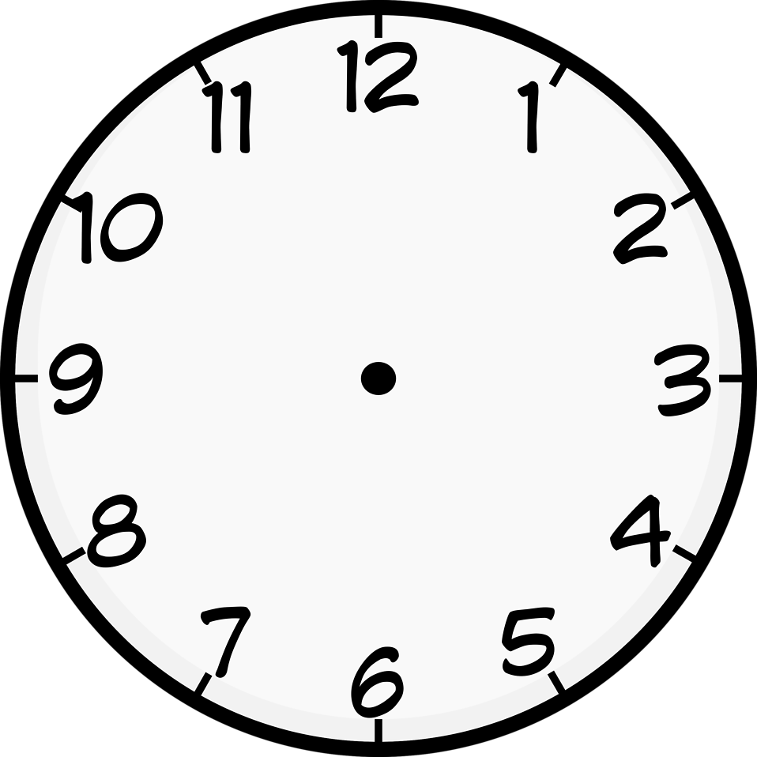

**o’clock**

**five past**

**ten past**

**quarter past**

**twenty past**

**twenty-five past**

**half past**

**twenty-five to**

**twenty to**

**quarter to**

**five to**

**ten to**

**What is the time?**

**What time is it?**

-------------------------------

***(geçe)***

**TO**

**PAST**

***(kala)***

**hour**

[**www.ingilizcele.com**](http://www.ingilizcele.com)

**minute**